AN OUTLINE OF THE STORY OF JESUS USING MAPS

The Land of Palestine at the time of Jesus of Nazareth, when, in J B Phillips words - Earth became a visited planet

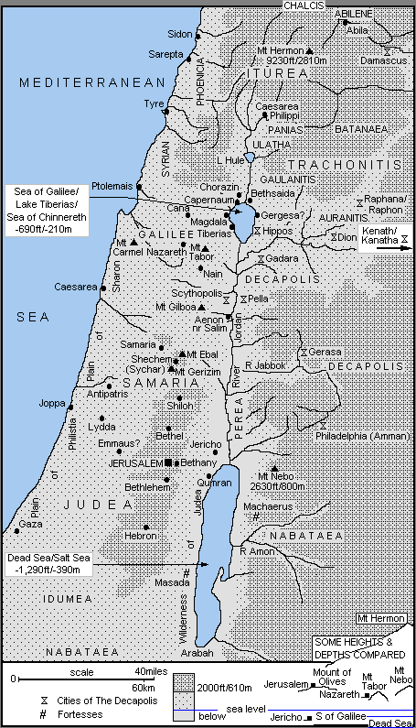

Map 1 - The Travels of Jesus as a Child and Young Man c 6BC-AD27

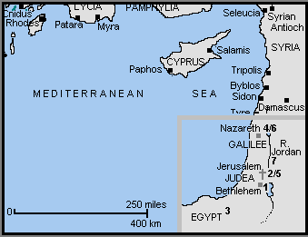

1] c 6BC - The Birth of Jesus at Bethlehem (Luke 2:4-7)
[2] Jesus is taken as a baby to Jerusalem for presentation at the Temple (Luke 2:22)
[3] c 4BC - Joseph and Mary take Jesus from Bethlehem to Egypt to escape the "massacre of the infants" by Herod the Great (Matthew 2:13-18)
[4] c 3BC - Joseph returns to Palestine from Egypt, but discovers Archelaus (a brutal man, later deposed) is now ruler of Samaria and Judea. The family settles in Nazareth in Galilee (Matthew 2:19-23)

Anno Domini or Christian Era

[5] c AD6 - The 12 year old Jesus travels from Nazareth to Jerusalem with his family, and stays behind in the Temple (Luke 2:41-46)
[6] c AD6-27 - On his return to Nazareth (Luke 2:51) according to tradition, Jesus stays for the next 20 or so years, and follows in his father's footsteps as a carpenter
[7] c AD27 - Jesus travels from Nazareth to the River Jordan to be baptised by John the Baptist (Matthew 3:13)

Map 2 - The Travels and Acts of Jesus in Year One of His Ministry c AD27-28

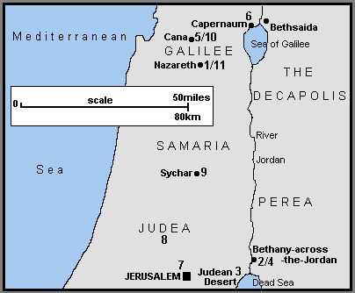

OPENING EVENTS

1] Jesus, now about 30 years old (Lk 3:23) travels from his home-town of Nazareth in Galilee
[2] At the River Jordan, possibly near Bethany-across-the-Jordan, he is baptised by John the Baptist (Mt 3:13; Mk 1:9)
[3] He goes in to the Judean Desert or wilderness to face the devil's temptation (Mt 4:1; Mk 1:12; Lk 4:1)
[4] At the River Jordan, near Bethany-across-the-Jordan, or Bethabara (Jn 1:28), and according to John's Gospel, Jesus calls his first five disciples (Jn 1:35). These include Philip, Andrew, and Simon Peter all from Bethsaida in Galilee (Jn 1:44)
[5] Jesus returns north to Galilee with his disciples (Jn 1:43), and at a wedding in Cana, changes the water into wine - his first recorded miracle (Jn 2:1)
[6] He continues on to Capernaum, on the northern shore of the Sea of Galilee with his mother, brothers and disciples, and stays there a short time (Jn 2:12)

EARLY MINISTRY IN JUDEA, SAMARIA and GALILEE

[7] He travels south to Jerusalem for the Passover - the first one mentioned in the Gospels (Jn 2:13). There he drives the money-changers from the Temple for the first time (Jn 2:14). He also meets the Pharisee, Nicodemus (Jn 3:1)
[8] Jesus leaves for the countryside of Judea where his disciples baptise believers (Jn 3:22)
[9] Jesus and his disciples continue northwards from Judea (Jn 4:3), passing through the territory of Samaria (Jn 4:4). Near Sychar, Jesus meets the Samaritan woman at the well (Jn 4:5). Many Samaritans believe in him (Jn 4:39), after which he continues on to Galilee (Jn 4:43)
[10] He reaches Galilee (Mt 4:12; Mk 1:14; Lk 4:14; Jn 4:45), and back in Cana heals the official's son who lays sick in Capernaum (Jn 4:46)
[11] Jesus returns to his home-town of Nazareth, and preaches in the synagogue (Lk 4:16). He is rejected for the first time (Lk 4:28)

Map 3 - The Travels and Acts of Jesus in Year Two of His Ministry c AD28-29

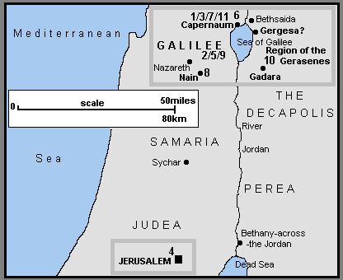

1] Jesus moves to Capernaum (Mt 4:13; Mk 1:21; Lk 4:31). According to the Synoptic Gospels, Jesus call his first disciples - perhaps only now to full-time service (Mt 4:18; Mk 1:16; Lk 5:1). In Capernaum he heals the madman in the synagogue (Mk 1:23; Lk 4:33) and Peter's mother-in-law of her fever (Mt 8:14; Mk 1:29; Lk 4:38)

FIRST PREACHING TOUR OF GALILEE

[2] Jesus travels throughout Galilee, preaching and healing (Mt 4:23; Mk 1:39), including the leper (Mt 8:2; Mk 1:40; Lk 5:12).
[3] Returning to Capernaum (Mk 2:1) a paralysed man is healed (Mt 9:2; Mk 2:3; Lk 5:18) and Jesus calls Matthew (or Levi) the tax-collector to be a disciple (Mt 9:9; Mk 2:14; Lk 5:27)
[4] Jesus travels from Galilee south to Jerusalem for a Jewish festival - possibly the Second Passover identified in the Gospels (Jn 5:1). At the Pool of Bethesda he heals the crippled man (Jn 5:2)
[5] Returning north to Galilee, Jesus heals the man with the shrivelled hand (Mt 12:9; Mk 3:1; Lk 6:6) and many others (Mt 12:15; Mk 3:7)
[6] On a hillside in Galilee, probably near Capernaum, he selects his twelve apostles (Mt 10:1; Mk 3:13; Lk 6:12) and delivers the Sermon on the Mount (Mt 5:1). In Luke's report Jesus comes down from a hillside to give the Sermon (Lk 6:20)
[7] Back in Capernaum, (Mt 8:5; Lk 7:1) Jesus heals the Roman centurion's servant (Mt 8:5; Lk 7:2)

SECOND PREACHING TOUR OF GALILEE

[8] Jesus continues preaching and healing in Galilee, and in Nain brings the widow's son back to life (Lk 7:11)
[9] Accompanied by the twelve apostles and some of his women helpers, Jesus continues his second Galilee tour (Lk 8:1)
[10] He sails across the Sea of Galilee (Mt 8:18; Mk 4:35; Lk 8:22) and calms a storm (Mt 8:24; Mk 4:37; Lk 8:23). Landing in the region of the Gerasenes (Mk 5:1; Lk 8:26) or Gadarenes (Mt 8:28) in Gentile Decapolis - the Ten Towns or Cities, Jesus heals the madman in the story of the Gadarene Swine (Mt 8:28; Mk 5:2; Lk 8:27)
[11] Sailing back across the Sea of Galilee (Mk 5:21) Jesus lands at "his own town" of Capernaum (Mt 9:1). Here he raises Jairus' daughter from the dead and heals the woman with the haemorrhage (Mt 9:18; Mk 5:22; Lk 8:41)

Map 4 - The Travels and Acts of Jesus in Year Three of His Ministry c AD29-30

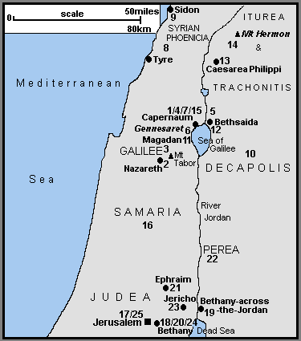

THIRD PREACHING TOUR OF GALILEE

[1] Jesus travels from Capernaum to "his own native town" of Nazareth ( Mk 6:1)
[2] In Nazareth, he is rejected for a second time (Mt 13:54; Mk 6:1)
[3] He continues through Galilee (Mt 13:58; Mk 6:6) and sends out the twelve apostles to preach the Gospel (Mt 10:5; Mk 6:7; Lk 9:1)
[4] The Twelve return to Capernaum from their mission (Mk 6:30, Luke 9:10)
[5] From Capernaum, they go off by boat with Jesus to a quiet place (Mk 6:32) near Bethsaida (Lk 9:10). Here he feeds the 5,000 (Mt 14:14; Mk 6:33; Lk 9:11; Jn 6:5)
[6] The disciples return across the Sea of Galilee (Mt 14:22; Mk 6:45), Jesus walking on the water to join them (Mt 14:25; Mk 6:48; Jn 6:19). They land near the Plain of Gennesaret and Jesus heals many people there (Mt 14:34; Mk 6:53)
[7] From Gennesaret they make their way back to Capernaum (Jn 6:24) and Jesus teaches about the Bread of Life (Jn 6:26)

JESUS PREACHES AND HEALS IN SYRIAN-PHOENICIA, ITUREA and TRACHONITIS, THE DECAPOLIS

8] Jesus retires from Galilee to the region of Tyre and Sidon in Syrian-Phoenicia (Mt 15:21; Mk 7:24) where he heals the daughter of the Gentile Syrophoenician woman (Mt 15:22; Mk 7:25).
[9] He leaves Syrian-Phoenicia via Sidon for Galilee (Mt 15:29) but travels through the Decapolis (Mk 7:31).
[10] In the Decapolis he heals the deaf and mute man (Mk 7:32) and feeds the 4,000 (Mt 15:32; Mk 8:1)
[11] Reaching the Sea of Galilee, he crosses by boat to the Magadan/Dalmanutha region (Mt 15:39; Mk 8:10). There the Pharisees and Sadducees ask for a sign from heaven (Mt 16:1; Mk 8:11)
[12] Continuing on to Bethsaida, a blind man is healed (Mk 8:22)
[13] Jesus now travels from Galilee, north to Caesarea Philippi in Iturea and Trachonitis, where Peter confesses that Jesus is the Christ (Mt 16:13; Mk 8:27)
[14] Continuing on from Caesarea Philippi possibly further north towards Mount Hermon, three of the disciples see Jesus Transfigured in the presence of Elijah and Moses (Mt 17:1; Mk 9:2; Lk 9:28). On his return, Jesus heals the boy with epilepsy (Mt 17:14; Mk 9:14; Lk 9:37). Other traditions place the Transfiguration to the south, on Mount Tabor. The epileptic boy would then have been healed in the Galilee area.
[15] In Galilee (Mt 17:22; Mk 9:30) in Capernaum (Mk 9:33), Jesus pays the Temple Tax with a fish! (Mt 17:24). Then to avoid the dangers in Judea, he remains in Galilee (Jn 7:1)

LATER MINISTRY IN JUDEA

[16] Jesus leaves Capernaum and Galilee for the last earthly time (Mt 19:1; Mk 10:1) and heads for Jerusalem (Lk 9:51; Jn 7:10). Travelling by Samaria, he heals the ten lepers (Lk 17:11) but is rejected in a Samaritan village (Lk 9:52)
[17] Arriving in Jerusalem for the Feast of the Tabernacles in the Autumn of c AD29 (Jn 7:10), Jesus forgives the woman caught in adultery (Jn 8:2) and heals the blind man who is taken before the Sanhedrin (Jn 9:1)
[18] During his travels in Judea, Jesus visits Martha and Mary in Bethany (Lk 10:38), returning to Jerusalem for "Hanukkah", the Feast of Dedication in December c AD29 (Jn 10:22)

THE LAST FEW MONTHS - c AD30

[19] Jesus withdraws to Bethany-across-the-Jordan (or Bethabara "where John had first baptised"), and into the province of Perea, and stays for a while (Jn 10:40)
[20] Following the death of Lazarus, Jesus returns to Bethany near Jerusalem, and raises him (Lazarus) from the dead (Jn 11:1).
[21] Because of threats to his life, Jesus withdraws to Ephraim to the north of Jerusalem (Jn 11:54)

HIS MINISTRY IN PEREA (MODERN JORDAN)

[22] He then crosses the River Jordan and works in Perea (Mt 19:1; Mk 10:1). There he blesses the little children (Mt 19:13, Mk 10:13; Lk 18:15) and speaks to the rich young man (Mt 19:16; Mk 10:17; Lk 18:18)

THE FINAL JOURNEY TO JERUSALEM

[23] Jesus now travels towards Jerusalem for the last time (Mt 20:17; Mk 10:32; Lk 18:31). Passing through Jericho he heals one (or two) blind men (Mt 20:29; Mk 10:46; Lk 18:35) and converts Zacchaeus the tax collector (Lk 19:1).
[24] Reaching Bethany (Jn 12:1) the home of Lazarus, Mary and Martha, Jesus is anointed by Mary either now (Jn 12:2), or later (Mt 26:6; Mk 14:3) after his triumphal entry into Jerusalem (Mt 21:1; Mk 11:1; Lk 19:29; Jn 12:12)
[25] During the Easter week, Jesus returns to Jerusalem each day after staying overnight in Bethany on the Mount of Olives (Mt 21:17-18; Mk 11:11-12;19; Lk 21:37).

Map 5 - The Galilee Area where Jesus Preached and Healed During Much of His Three Year Ministry

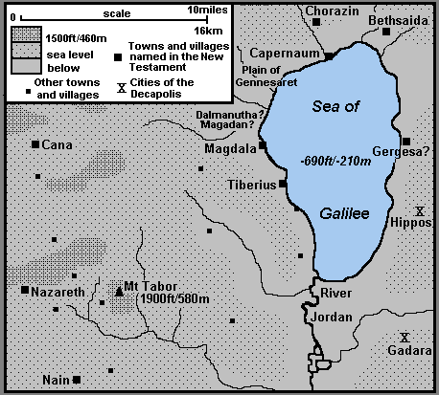

HIS TRAVELS and ACTS

Map 6 - The Miracles of Nature of Jesus

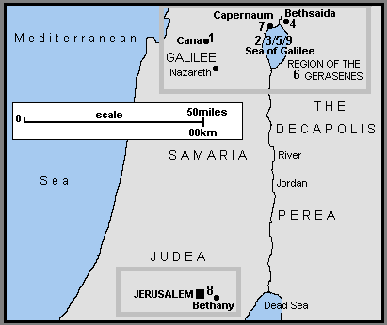

Year One - c AD27-28
[1] Cana - Water into wine
Year Two - c AD28-29
[2] Sea of Galilee - The first miraculous catch of fish
[3] Sea of Galilee - Calming the storm
Year Three - c AD29-30
[4] Near Bethsaida - Feeding the five thousand
[5] Sea of Galilee - Walking on water
[6] Region of the Gerasenes - Feeding the four thousand
[7] Capernaum - A fish pays the Temple tax!
The Last Week in Jerusalem - Spring c AD30
[8] Bethany to Jerusalem - The cursed fig-tree that withers way
After the Resurrection
[9] Sea of Galilee - The second miraculous catch of fish

Map 7 - The Healing Miracles of Jesus

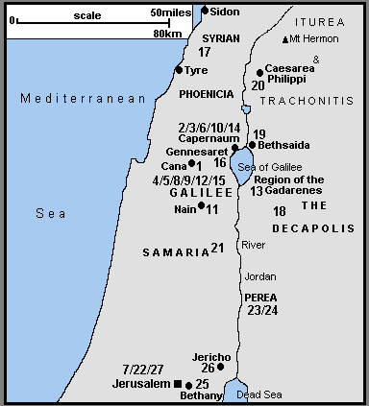

Year One - cAD27-28
[1] Cana - The officials' dying son
Year Two - c AD28-29
[2] Capernaum - The madman in the synagogue
[3] Capernaum - Peter's mother-in-law's fever: Jesus also heals many others that evening
[4] Galilee - Jesus continues preaching and healing
[5] Galilee - The leper
[6] Capernaum - The paralysed man
[7] Jerusalem - The invalid at the Pool of Bethesda
[8] Galilee - The man with the shrivelled hand
[9] Galilee - Jesus continues healing many
[10] Capernaum - The Roman centurion's servant
[11] Nain - Raising the widow of Nain's dead son
[12] Galilee - The dumb (and blind) man
[13] Region of the Gadarenes - The madman (or men) and the Gadarene swine (or pigs)
[14] Capernaum -The woman with the haemorrhage, and the raising of Jairus' daughter
[15] Galilee - Two blind men and the dumb man
Year Three - c AD29-30
[16] Gennesaret - Jesus heals the sick
[17] Tyre-Sidon Region - The sick daughter of the Syrophoenician woman
[18] The Decapolis - The deaf and dumb man
[19] Bethsaida - The blind man
[20] Caesarea Philippi - The epileptic boy
[21] Samaria - The ten lepers
[22] Jerusalem - The man born blind who goes before the Pharisees
The Last Months - c AD29-30
[23] Perea? - The crippled woman
[24] Perea? - The man with dropsy
[25] Bethany - Lazarus raised from the dead
[26] Jericho - The blind men near Jericho
The Last Week in Jerusalem - Spring c AD30
[27] Jerusalem - Healing the severed ear of the High Priest’s servant

Map 8 - The City of Jerusalem and its Eastern Approaches

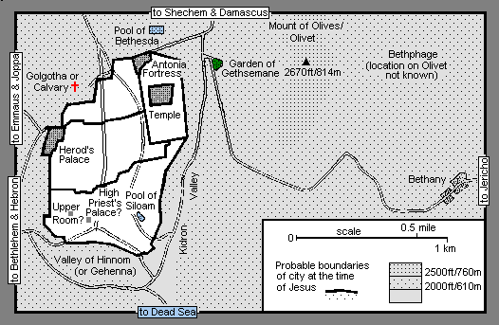

Map 9 - The Movements of Jesus During His Last Week in the Jerusalem Area Spring c AD30

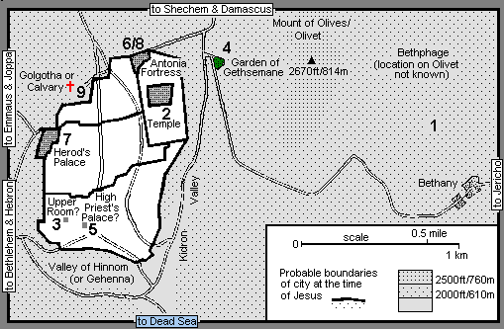

THE SUNDAY BEFORE EASTER
[
1] From the area of the two villages of Bethphage and Bethany, Jesus makes his triumphal entry into Jerusalem (Mt 21:1; Mk 11:1; Lk 19:29; Jn 12:12).
Each night he returns to Bethany (Mt 21:17-18; Mk 11:11-12, 19; Lk 21:37)

MONDAY TO THURSDAY

[2] Jesus concludes his confrontations with the religious establishment, often in Jerusalem and the Temple area. The plots to arrest and have him killed progress (Part 21). He describes the end-times and his return (Part 22); is possibly anointed at this time at Bethany (Part 23); and Judas Iscariot decides to betray him (Part 24)

THURSDAY EVENING AND NIGHT

[3] In the "Upper Room" (Mt 26:17; Mk 14:12; Lk 22:7) Jesus holds the Last Supper (Mt 26:20; Mk 14:17; Lk 22:14) and the apostles receive the bread and wine as his body and blood (Mt 26:26; Mk 14:22; Lk 22:19)
[4] After the Last Supper, Jesus and his disciples cross the Kidron (or Cedron) Valley just outside Jerusalem, to the western edge of the Mount of Olives (Mt 26:30; Mk 14:26; Lk 22:39; Jn 18:1). There in the Garden of Gethsemane as he prays, the disciples fall asleep (Mt 26:36; Mk 14:32; Lk 22:40)

GOOD FRIDAY

[5] Jesus is arrested in the Garden of Gethsemane (Mt 26:47; Mk 14:43; Lk 22:47; Jn 18:3) and taken to the High Priest's Palace (not the Temple) for questioning (Mt 26:57; Mk 14:53; Lk 22:54; Jn 18:13). He then appears before members of the Council or Sanhedrin (Mt 26:59; Mk 14:55; Lk 22:66)
[6] The members of the Sanhedrin escort Jesus to the Judgement Hall or Praetorium (the Roman governor's residence, probably in the Antonia Fortress) for interrogation and sentence by Pontius Pilate (Mt 27:2,11; Mk 15:1; Lk 23:1; Jn 18:28)
[7] Pontius Pilate sends Jesus to Herod's Palace, the Jerusalem residence of the Jewish tetrarch of Galilee and Perea, Herod Antipas, for further questioning (Lk 23:6)
[8] On being taken back to Pontius Pilate (Luke 22:11) in the Antonia Fortress, Jesus is sentenced to death (Mt 27:26; Mk 15:15; Lk 23:24; Jn 19:16). He is also flogged and tortured
[9] - Jesus is taken from the Judgement Hall to Golgotha or Calvary - the Place of the Skull (Mt 27:31; Mk 15:20; Lk 23:26; Jn 19:16) where he is crucified (Mt 27:35; Mk 15:24; Lk 23:33; Jn 19:18)
Place of the Skull - "Golgotha" in Aramaic and Hebrew. "Calvary" = Calvaria, or "skull" in Latin

Map 10 - The Appearances of Jesus to His Followers, including Stephen and Paul, after His Resurrection

There is no complete agreement by the various commentators on precisely how many different appearances Jesus made to his disciples

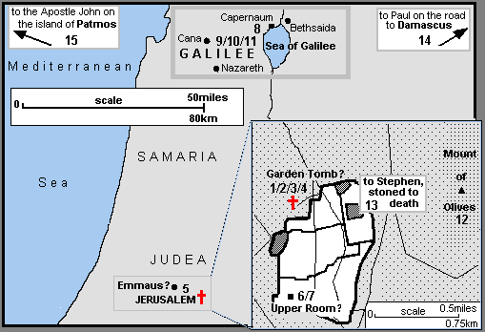

GOOD FRIDAY

[1] Golgotha or Calvary - Jesus is taken from the cross and placed in the garden tomb (Mt 27:57; Mk 15:42; Lk 23:50; Jn 19:31)

EASTER SUNDAY IN AND AROUND JERUSALEM

[2] The Garden Tomb - Jesus appears to Mary Magdalene outside the tomb (Mk 16:9; Jn 20:11)
[3] The Garden Tomb - To Mary Magdalene and the other Mary (the mother of James the Younger and Joses - Mk 16:1) as they hurry from the tomb (Mt 28:8)
[4] The Garden Tomb - To Peter (Lk 24:34; "Cephas" in 1Co 15:5)
[5] The Road to Emmaus - To two disciples on the Emmaus road later in the day (Mk 16:12; Lk 24:13)
[6] The Upper Room - To the apostles in a house in Jerusalem (Luke 24:36; Jn 20:19). Possibly the Upper Room where the Last Supper was held; Thomas was absent according to John 20:24.

A WEEK LATER

[7] The Upper Room - To the eleven apostles, including Thomas in a house; probably the same house as [6] (Jn 20:26; possibly Mk 16:14)

OVER THE NEXT WEEKS IN GALILEE

[8] The apostles go to Galilee (Mt 28:16a); there Jesus appears to seven of them fishing on the Sea of Galilee (Jn 21:1)
[9] Jesus appears to the apostles on a mountain and gives his great commission to preach the Gospel to the world (Mt 28:16b)
[10] More than 500 disciples in Galilee (1Co 15:6)
[11] To James, his brother (1Co 15:7)

ASCENSION DAY NEAR JERUSALEM
[12] To the apostles on the Mount of Olives (Olivet), near Bethany, as he ascends to Heaven (Lk 24:50, Acts 1:12)

AFTER HIS ASCENSION
[13] To Stephen as he is stoned to death in Jerusalem (Ac 7:55)
[14] To Paul on the road to Damascus (Ac 9:3; 26:13; 1Co 15:8)
[15] To John in a vision on the island of Patmos (Rev 1:10)

Map 11 - Locations where the Original Apostles Preached the Gospel of Jesus Christ According to Various Ancient traditions

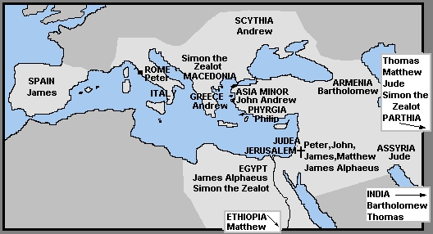

OUTLINE OF THE STORY OF JESUS USING MAPS
From
J B Phillips’ Translation of the New Testament

