[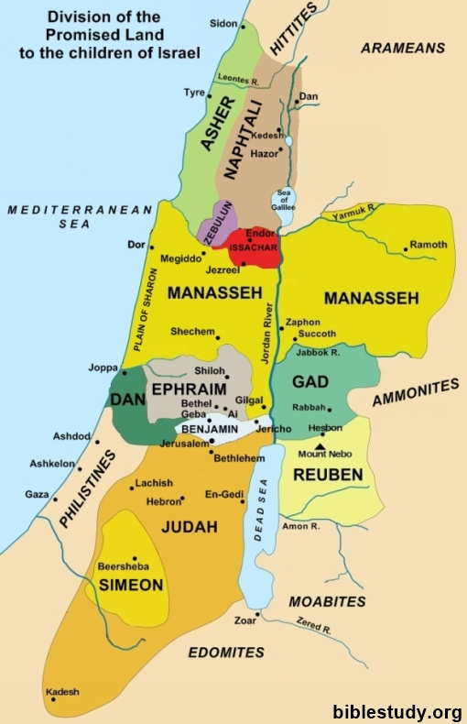](http://www.biblestudy.org/maps/division-of-promised-land-to-twelve-tribes-israel.html)