The word type is borrowed from the Greek tupos,
which is a mark formed by a blow or impression, hence a figure or image.
Right now you are reading the mark made by typeface,
each letter, word and paragraph conveying by the use of agreed-upon symbols
the thoughts which have been set in "type."
We use the word typical, meaning that which bears the impress of
some distinctive pattern of design, thought, and so on.
So if we want to draw our definition of a biblical type from this basic data,
then we can see widespread use of types in the Bible.

Allegories and Types
Basics of Bible Interpretation
By Elaine Stedman

A considerably advanced degree of interpretive skill is needed for unraveling the truth woven into allegories and types. But note that in every case there are known quantities which by comparison and correspondence are designed to lead us to an understandable interpretation. It is not surprising that there are extremes of interpretive opinion regarding these forms, as the interpreter's task is an imposing one. On the one hand we view with alarm the excesses of some of the early church fathers, who took such leaps of interpretive fancy that the whole idea of types and allegories has been discredited, or at least discounted, by some modern Bible scholars as what they call "allegorizing" or "spiritualizing" the text. On the other hand, since these figures are identifiable in the Bible itself when it uses the term "type" or "allegory," we do well not to throw out that which God has apparently determined to use. He is so much more imaginative than we are! So, being willing to face the difficulties, let's give God a chance to enlighten us with the communication tools he has devised.

Allegories

The one allegory in the Bible that is so labeled is in Galatians 4:21-31 NASB: "Now this is an allegory" Paul says in Galatians 4:24 NASB.

So we have at least one identifiable example of this figure of speech. Paul writes,

Tell me, you who desire to be under law, do you not hear the law? For it is written that Abraham had two sons, one by a slave and one by a free woman. But the son of the slave was born according to the flesh, the son of the free woman through promise. Now this is an allegory: these women are two covenants. One is from Mount Sinai, bearing children for slavery; she is Hagar. Now Hagar is Mount Sinai in Arabia; she corresponds to the present Jerusalem, for she is in slavery with her children. But Jerusalem above is free, and she is our mother (Galatians 4:21-26 NASB).

At first look, our task seems rather formidable, but let's try to sort out the pieces that correspond. I suggest the key is, "...these women are two covenants." So I proceed to try to sort out the various references under these headings.

I read the context in the book of Galatians, also the Old Testament account to which Paul is referring (Genesis 15-17 NASB and Genesis 21:1-21 NASB), so that I'll have the whole story in mind, and here's what I see as a result:

Two Covenants
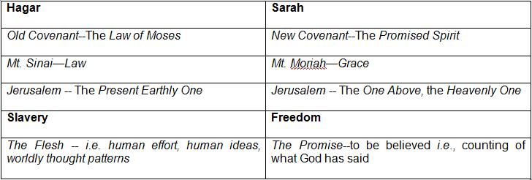
We can see even more if we use another key phrase, "Now we, brethren, like Isaac, are children of promise" (Galatians 4:28). This suggests another comparison.

Two Kinds of Children
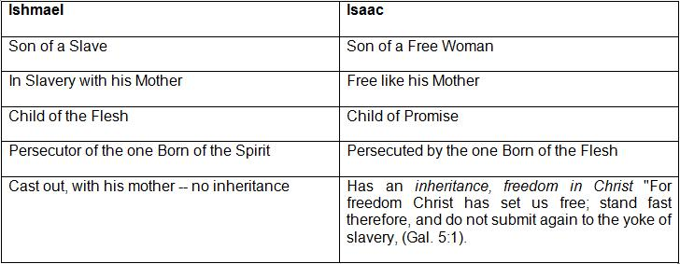

"We" Christians, says Paul, "are like Isaac!" And, by implication at least, not like Ishmael.

And when you reflect that in Galatians Paul is addressing Gentile Christians, it seems as if he expected a great deal from them, interpretively. How could they grasp such a far-out figure? Well, it's not hard to envision when we remember he was countering the arguments of the Judaizers, who had taught these Galatians that the works of the law were necessary, for salvation and for sanctification. Where but to the Old Testament (from which these false teachers quoted) would Paul go to expose their fallacies?

What interpretive principles can we draw from this biblical example of allegory? Here's what I see:

1. Allegory is a bona-fide figure of speech used in the Bible.
2. It employs comparison and correspondence of words and ideas.
3. It is illustrative and explanatory of a specific line of truth.
4. It cannot be divorced from its local context or the historical narrative from which it is drawn.
5. It is comprised of a number of metaphorical expressions in which the meaning of one word is invested in another, e.g. Hagar is Mt. Sinai, that is, she represents the Law of Moses.
6. None of the figurative expressions are so obscure as to leave us guessing as to their import.
7. We can expect to learn something from their use that will be of profit--applicable to life.
8. We would be wise not to assume that such hidden meanings are latent in every place in the Bible.

Are there other legitimate uses of allegory in the Bible, even though not specifically identified as such? I don't know. This is the only one specifically identified in the New Testament by the Greek word which we translate "allegory." What is important, and what I do know, is that God wants us to recognize that here he has established a valid vehicle of communication using the idea of word correspondence, in which one word can represent all the implications of a broad concept (Hagar = Mt. Sinai = the Law).

Certainly we see the same sort of thing, though not so elaborately spelled out, in "For Christ our Passover also has been sacrificed" (1 Corinthians 5:7 NASB). Here the mind turns immediately to the question, in what ways does the Passover picture the Lord Jesus in his sacrifice? So we turn back to Exodus 12 where the Passover was instituted by God and proceed to think it through. I would commend it to you as a most enlightening exercise of your interpretive skill.

The same feature of correspondence is true of "...all drank the same spiritual drink, for they were drinking from a spiritual rock which followed them; and the rock was Christ" (1 Corinthians 10:4 NASB). Again our minds are drawn back to Israel's wilderness journey to investigate what God had in mind for us to learn through this mind-intriguing method of teaching. Whether we call these allegories or not is unimportant as long as we discover their hidden truths. However, I'm inclined to think there are more allegories hidden in the Bible than we give God credit for. Stuart Briscoe, in his delightful and careful treatise on Ezekiel 1 is not ashamed to say so. He calls Ezekiel's bizarre acting-out of the "Word of the Lord" allegorical. In trying to interpret this difficult book, one is inclined to agree.

Types

It is exceedingly unfortunate that modern scholarship has succeeded in almost eliminating the investigation and teaching of typology as a valid interpretive pursuit. So much has been lost of the richness and practical illustrative value which I believe God intends we should have through an understanding of types. I would like to try to regain something of this lost value, using the Bible itself as the foundation for its validity.

Typology is a bad word in many theological circles, but it is not difficult to see that God has a use for it, even if we do not. It is easy to see why many have reacted adversely to this field of biblical interpretation, for one only needs to read some of the writings of the past centuries to see the tendency to overreach in this obviously fascinating use of figurative language.

Much of the problem would be resolved, however, by simply agreeing on what a type is. The definition can be broad or narrow, based on the source of information we employ. I would remind you once again, the word type is borrowed from the Greek tupos, which is a mark formed by a blow or impression, hence a figure or image. Right now you are reading the mark made by typeface, each letter, word and paragraph conveying by the use of agreed-upon symbols the thoughts which have been set in "type." We use the word typical, meaning that which bears the impress of some distinctive pattern of design, thought, and so on. So if we want to draw our definition of a biblical type from this basic data, then we can see widespread use of types in the Bible such as one can read in Wilson's Dictionary of Bible Types. (Pat's note: Also see NTS Dictionary of Bible Types.)

Dr. Walter Wilson's "types" range from items like:

YOKE

Genesis 27:40b This type is used to indicate the oppression and repression placed upon one person by another person, or upon one nation by another nation.

Matthew 11:29b This term is used to indicate the blessed union for service which the Lord desires on the part of His people. The Christian, walking with the Lord and serving Him, finds the work to be easy, and the load is light.

2 Corinthians 6:14b In this case the yoke represents an unhappy union of those who are saved with those who are unsaved in any service or work. The Lord commands His people to be linked up only with Christians, and not with those who belong to Satan's family. This refers to marriage, to business, and to every other form of union. This situation is complicated frequently by those who are saved, born again, after the union is made. God made provision for this situation in various parts of His Word. (2)

to his entry on:

SCAPEGOAT

Leviticus 16:8b The goats in this story represent two aspects of the sacrifice of the Lord Jesus. The live goat which became the scapegoat is a picture of the Savior living in glory with the marks of Calvary upon Him, having taken away the sin of the world, and having died at Calvary for our sins. The dead goat represents Christ at Calvary, giving up His life for us. (3)

Certainly these are figurative words containing the feature of correspondence to which we have alluded, but they differ widely in their usage. The word yoke has general usage as implying "two joined together in a working union," while the word scapegoat has a specific identification with the sacrifices ordered under the Levitical priesthood. To make any sense at all, this latter word must be viewed in the tight context of Leviticus 16. I question whether yoke should be called a type; however, scapegoat comes much closer to the biblical significance of that term, in my estimation.

We can draw the lines a bit tighter if we say a type is a person or thing prefiguring a future person or thing; or a figure or example of something future and more or less prophetic called the antitype. Then we can define the antitype as: a thing formed after some pattern, or a thing resembling another, its counterpart--or something which answers to a type. Essentially, I see a type as a figurative expression picturing, in shadow form, an identifiable reality elsewhere presented in scripture. Both type and antitype are New Testament biblical terms, as we shall illustrate later.

My own composite expression of all I have grasped on the subject is this: I see a type as being a premeditated resemblance which God has built into the Bible and history to illustrate and teach truth---to make it easier to grasp than if it were only stated in prosaic and propositional terms. It is a kindness of God to stir our minds and imagination by the use of types --to make an unforgettable impress. I see it as God's way of "putting his brand on our brain" so that we cannot escape the impact of truth.

Under the general heading of typology, then, we could group various terms, all derived from scripture, portraying slightly different forms of this figure. I would like to list these and illustrate each one.

Typology
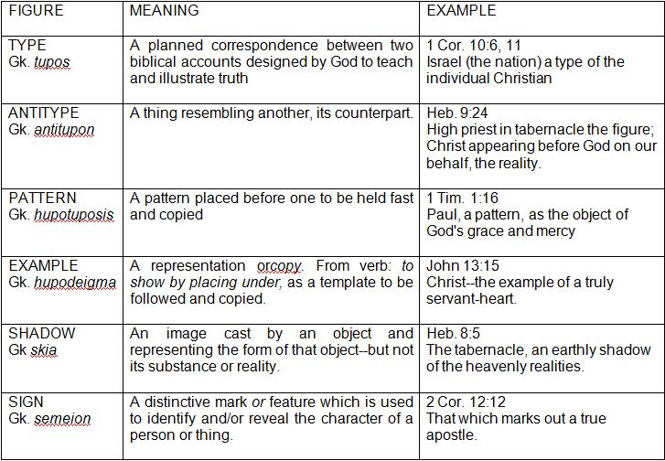

Perhaps it would be helpful to identify the use of some of these words in the New Testament to see their use in context:

1. Tupos

John 20:25 print (or mark) of the nails

Acts 7:43 figures (idol images) of foreign gods

Acts 23:25 a letter of this type (following this pattern) or "to this effect"

Romans 5:14 Adam, a type (or pattern) of Christ

Romans 6:17 a type (or standard) of teaching

1 Corinthians 10:6 these things (Israel's history, the rock picturing Christ, etc.) are types.

1 Corinthians 10:11 now these things happened to them typically, for our admonition.

Philippians 3:17 you have us as a type (or pattern)

1 Thessalonians 1:7 so you became a type (or pattern) to all that believe.

1 Timothy 4:12 but you became a type (or pattern) of the believers, in speech and behavior.

Titus 2:7 in all things showing yourself a pattern of good works.

Hebrews 8:5 make all things according to the pattern shown to you in the mount

1 Peter 5:3 becoming examples to the flock

Here we see all the uses of tupos in the Greek New Testament and can identify the various meanings given to this word, all relating to its basic import, but some becoming a much more extensive and formal usage, as we can determine by setting them in their context.

For instance, the "print" (tupos) of the nails in the hands of Jesus obviously carries the basic sense of "a mark made by striking a blow," and we do not look for any deeper meaning than this. On the other hand, when we see that "Adam...was a type of the one who was to come" (i.e. Christ) we are immediately alerted to seek the answer to the question, "In what way?" Certainly he was not a type in reference to sin, since Adam began the pattern of disobedience we have all perpetuated, while the Lord Jesus never sinned. So as we read the whole of Romans 5, we have a study in comparisons and contrasts in which we see that the way Adam typified Christ is that each was the source and beginning of a far-reaching fallout of consequences that have affected the whole of mankind. Here is the resemblance--and the theological implications are terrific! A clear understanding of this comparison in Romans 5 is a wide-open window toward understanding God and man.

Then there's the clearly specified typology of the resemblance (whether by comparison or contrast) of the Old Testament priesthood of Aaron and of Melchizedek with the high-priestly ministry of the Lord Jesus. In Hebrews 8:5 we have three of the words in our chart:

"They (the Old Testament tabernacle and priesthood) serve a copy (hupodeigma) and shadow (skia) of the heavenly sanctuary; for when Moses was about to erect the tent he was instructed by God, saying, 'See that you make everything according to the pattern (tupos) which was shown you in the mountain.'"

Certainly here is the clear declaration of God's intent to implant deeply significant truth in the worship and form of the tabernacle, investing deep levels of truth in the physical forms and actions to impart spiritual understanding. Evidently God gave Moses a blueprint--not just of form and furniture, but of the shadows and examples woven into his pattern, pointing to the realities which they picture. Our understanding of the Book of Hebrews revolves around our tracing through these analogies.

But the anchor point for our basic approach to the study of types rests in 1 Corinthians 10 NASB.

Now these things are types of us, so that we might not be craving after evil things as indeed those were craving (1 Corinthians 10:6 NASB, literal rendering)

And again:

These things happened to those men typically and were written down for admonition of us upon whom the ends of the ages have come down (1 Corinthians 10:11 NASB, literal rendering).

Here is a wide-open door of typical teaching, for Israel is cited as an example, essentially a negative one, warning us against doing as they did. The target for the truth thus communicated is specifically designated as Christians in this later age, the church age. But how do we identify the point of analogy? Is each Israelite a type, or the nation? I have found that the key to a consistent application of this typology is to recognize that the nation Israel is picturing the individual Christian. When we keep that in mind the analogy fits and we can learn the lessons God has for us in this type.

Let's explore Israel's wilderness experience as an example to see if (1) we can match the type with its antitype, and (2) learn the needed lessons.

Hebrews 3:12 NASB, speaking of Israel's wilderness wanderings says:

"Take care, brethren, lest there be in you an evil, unbelieving heart, leading you to fall away from the living God" (Hebrews 3:12 NASB).

It seems we should learn an important lesson from Israel's experience — but what lesson?

Reviewing Israel's history, we start with her departure from Egypt (the beginning of redemption) and follow her story into the land of promise (the place of rest). Let's trace it through. In Exodus 12; 13, beginning with the Passover, we see God's preparation for Israel's release from slavery; the Red Sea crossing and the wilderness journey is the trial of their faith; the entry and conquest of the land is entering into the victory and fulfillment of being in the place of God's appointment, despite obstacles.

Please read at least Exodus 3; 4; 12; 13; Numbers 13; 14; Deuteronomy 34; Joshua 1; 2; 3; 4; 5; 6; 7; 8 to get the most out of this study. Then correlate with Hebrews 3; 4.

in the New Testament.

Release from Slavery

The beginning of freedom is Christ--our Passover (1 Corinthians 5:7). This expression cites an obvious analogy, but what are the similarities? We discover them by reading Exodus 3-13 to get the background, observing especially Exodus 12, as it relates to Christ our Passover in 1 Corinthians 5:7, noting the resemblance features. Christ is the reality-- the Passover is the shadow.

A Lamb Slain--a picture of redemption, setting free from bondage and death (John 1:29). Christ died for us.

Blood Sprinkled--application and identification, the activity of faith (John 6:27-29).
The Lamb Eaten--strength and sustenance for life (John 6:53).

Unleavened Bread--strength for life's journey based on the putting away of sin and feeding on Christ. Corresponds to Christ the Bread of Life in John 6. (See also 1 Corinthians 5:6-8)

Circumcision--the mark of God's ownership, the judging of the principle of independent self-effort (cutting off the flesh) (Colossians 2:9-11, Philippians 3:3).

Readiness to Travel--a willingness to move out at God's command--out of bondage into the place of freedom and victory.

The Trial of Faith

The Dead Sea--God's power to deliver through the tight spots. Also his cutting off the way back--no returning to the former bondage.

Israel--(prince with God, or one who prevails with God) is a picture of the Christian believer.

Egypt--bondage to Satan as god of this world, through the appeal of the world.

Dying in the Wilderness--the result of unbelief--always death.

Manna--God's sustaining grace even in the face of rebellion.

Jordan River--the trial of faith: to repudiate the flesh and obey God despite circumstances and feelings (the flood condition). Corresponds to our experience of Romans 6--we died with Christ, thus freed from sin's power.

Entering God's Rest

Canaan--the place of victory and rest in the midst of conflict.

Caleb--the typical man of faith--conquering through God's power.

Jericho--conquest and victory through faith in the certain Word of God. The foolishness of God is wiser than men (1 Corinthians 1:25).

Ai--(a heap of ruin) defeat through self-confidence and incomplete obedience.

Giants--seemingly invincible, unconquerable obstacles.

Possessing the land--(only as the soles of their feet trod the ground) the walk of faith, taking possession of what is already ours--believing and acting on God's promises.

Moses--not able to enter the land--the Law's inability to get us into the place of rest and victory.

Joshua--a picture of Jesus (same word) as the trailblazer or pioneer of faith who is able to lead us into the place of victory and rest.

Our research has taken us through large portions of Exodus, Numbers, Deuteronomy, and Joshua in the Old Testament, while Hebrews 3; 4 presents the New Testament application of the type. Here we see the imperative nature of a life of faith, of fully entering God's rest. By contrast, we can see in Numbers 13:17 to Numbers 14:35 (Numbers 13:17-14:35) the fatal consequences of unbelief. Through all this, Israel pictures in physical, historical terms the spiritual realities of the Christian life of a New Testament believer in Christ.

In application, we are here presented with clear testimony that we must believe God's Word and act on his promises if we are to enjoy a life of fulfillment and victory over the enemy forces. REST should be a most important word in the Christian vocabulary--and it is only experienced through the obedience of faith.

"Therefore, while the promise of entering his rest remains [like today] let us fear lest any of you be judged to have failed to reach it. For good news came to us just as to them." (Hebrews 4:1-2).

In this rather telling illustration we can discern something of the value of the study of types, for they have the capacity to make an indelible impression on the mind and heart in a uniquely helpful way. If you are yet unconvinced, I suggest you read the highly interesting treatment of the book of Esther by my fellow-pastor, Ray Stedman. His book is titled The Queen and I. The clincher, for me, on the typological nature of Esther is the Hebrew names of Haman's ten sons as Mr. Stedman points out in Chapter 10. Read it and see what you conclude, will you?

Some years ago I endeavored to pin down some principles for interpreting symbols and types, and as I review my conclusions, I feel they are still valid. Here are my suggestions. I hope you will find them helpful.

Biblical Symbols and Types

Rules for Interpretation

1. Look for the basic meaning of the symbol. Go beyond the superficial.

2. The physical is often used to picture the spiritual.

3. Look for the consistent use of a specific symbol in the Old Testament.

4. The symbol or type must be an illustration of and consistent with New Testament truth.

5. Recognize that the Old Testament teaches the same truth as the New Testament.

6. Don't expect the type to cover every subject of theology--limit to the topic under consideration in the context.

7. Assume that details given have meaning--seek to discover that meaning. However, don't expect every detail to fit. Every analogy, by its very nature, falls short of the full reality.

8. Identify interpretational constants by determining an accurate definition of any type or symbol which fits all the uses of that term in Scripture, e.g. "Lion" symbolizes power, whether applied to Satan as "a roaring lion" or to Christ as the "lion of the tribe of Judah."
~~~~~~~~~~~~~~~~~~~~~~~~~~~~~~~~~~~~~~~~~~~~~~~~~~~~~~~~~~~~~~~~~~~~~~~~~~~~~
Ray Stedman Organization - Allegories and Types by Elaine Stedman

References:
1. Stuart Briscoe, All Things Weird and Wonderful (Wheaton: Victor Books, 1977), p. 118.
2. Walter L. Wilson, Dictionary of Bible Types (Grand Rapids: William B. Eerdmans Co., 1957), p. 519.
3. Ibid., p. 396.
Copyright © 2009 by Elaine Stedman — This material is the sole property of Ray Stedman Ministries. It may be copied only in its entirety for circulation freely without charge. All copies and/or of this data file must contain this copyright notice. This data file may not be copied in part, edited, revised, copied for resale or incorporated in any commercial publications, recordings, broadcasts, performances, displays, or other products offered for sale without the written permission of Ray Stedman Ministries. This material is from the Official Ray C. Stedman Library web site at http://www.RayStedman.org. Requests for permission to use this material or excerpts thereof should be directed to webmaster@RayStedman.org. This Copyright notice supercedes all other Copyright notices.
Copies of any message or sermon translations must be furnished to webmaster@RayStedman.org in PDF format, with contact information and qualifications concerning the translator(s) provided separately in English.

