An Outline of The Story of Jesus Using Maps
From J B Phillips’ Translation of the New Testament

The Land of Palestine at the time of Jesus of Nazareth, when, in J B Phillips words - Earth became a visited planet

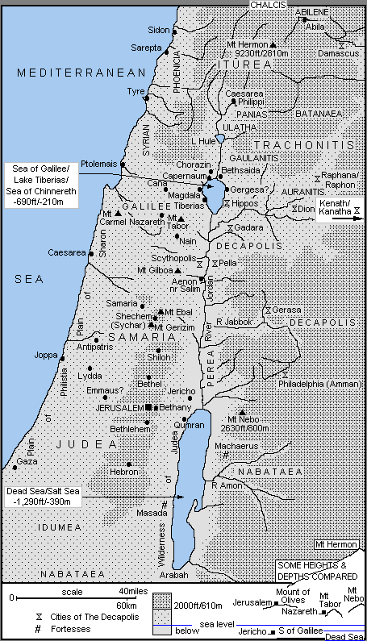

Map 1 - The Travels of Jesus as a Child and Young Man c 6BC-AD27

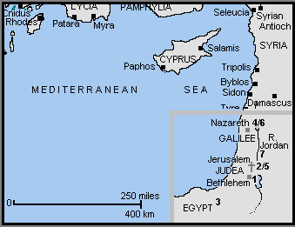

[1] c 6BC - The Birth of Jesus at Bethlehem (Luke 2:4-7)

[2] Jesus is taken as a baby to Jerusalem for presentation at the Temple (Luke 2:22)

[3] c 4BC - Joseph and Mary take Jesus from Bethlehem to Egypt to escape the "massacre of the infants" by Herod the Great (Matthew 2:13-18)

[4] c 3BC - Joseph returns to Palestine from Egypt, but discovers Archelaus (a brutal man, later deposed) is now ruler of Samaria and Judea. The family settles in Nazareth in Galilee (Matthew 2:19-23)

Anno Domini or Christian Era

[5] c AD6 - The 12 year old Jesus travels from Nazareth to Jerusalem with his family, and stays behind in the Temple (Luke 2:41-46)

[6] c AD6-27 - On his return to Nazareth (Luke 2:51) according to tradition, Jesus stays for the next 20 or so years, and follows in his father's footsteps as a carpenter

[7] c AD27 - Jesus travels from Nazareth to the River Jordan to be baptised by John the Baptist (Matthew 3:13)

Map 2 - The Travels and Acts of Jesus in Year One of His Ministry c AD27-28

OPENING EVENTS

[1] Jesus, now about 30 years old (Luke 3:23) travels from his home-town of Nazareth in Galilee

[2] At the River Jordan, possibly near Bethany-across-the-Jordan, he is baptised by John the Baptist (Matthew 3:13; Mark 1:9)

[3] He goes in to the Judean Desert or wilderness to face the devil's temptation (Matthew 4:1; Mark 1:12; Luke 4:1)

[4] At the River Jordan, near Bethany-across-the-Jordan, or Bethabara (John 1:28), and according to John's Gospel, Jesus calls his first five disciples (John 1:35). These include Philip, Andrew, and Simon Peter all from Bethsaida in Galilee (John 1:44)

[5] Jesus returns north to Galilee with his disciples (John 1:43), and at a wedding in Cana, changes the water into wine - his first recorded miracle (John 2:1)

[6] He continues on to Capernaum, on the northern shore of the Sea of Galilee with his mother, brothers and disciples, and stays there a short time (John 2:12)

EARLY MINISTRY IN JUDEA, SAMARIA and GALILEE

[7] He travels south to Jerusalem for the Passover - the first one mentioned in the Gospels (John 2:13). There he drives the money-changers from the Temple for the first time (John 2:14). He also meets the Pharisee, Nicodemus (John 3:1)

[8] Jesus leaves for the countryside of Judea where his disciples baptise believers (John 3:22)

[9] Jesus and his disciples continue northwards from Judea (John 4:3), passing through the territory of Samaria (John 4:4). Near Sychar, Jesus meets the Samaritan woman at the well (John 4:5). Many Samaritans believe in him (John 4:39), after which he continues on to Galilee (John 4:43)

[10] He reaches Galilee (Matthew 4:12; Mark 1:14; Luke 4:14; John 4:45), and back in Cana heals the official's son who lays sick in Capernaum (John 4:46)

[11] Jesus returns to his home-town of Nazareth, and preaches in the synagogue (Luke 4:16). He is rejected for the first time (Luke 4:28)

Map 3 - The Travels and Acts of Jesus in Year Two of His Ministry c AD28-29

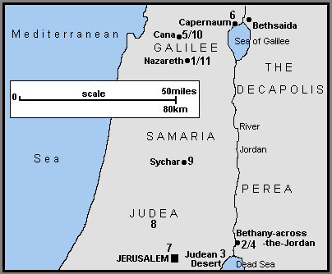

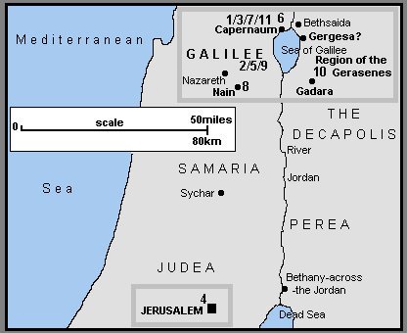

[1] Jesus moves to Capernaum (Matthew 4:13; Mark 1:21; Luke 4:31). According to the Synoptic Gospels, Jesus calls his first disciples - perhaps only now to full-time service (Matthew 4:18; Mark 1:16; Luke 5:1). In Capernaum he heals the madman in the synagogue (Mark 1:23; Luke 4:33) and Peter's mother-in-law of her fever (Matthew 8:14; Mark 1:29; Luke 4:38)

FIRST PREACHING TOUR OF GALILEE

[2] Jesus travels throughout Galilee, preaching and healing (Matthew 4:23; Mark 1:39), including the leper (Matthew 8:2; Mark 1:40; Luke 5:12).

[3] Returning to Capernaum (Mark 2:1) a paralysed man is healed (Matthew 9:2; Mark 2:3; Luke 5:18) and Jesus calls Matthew (or Levi) the tax-collector to be a disciple (Matthew 9:9; Mark 2:14; Luke 5:27)

[4] Jesus travels from Galilee south to Jerusalem for a Jewish festival - possibly the Second Passover identified in the Gospels (John 5:1). At the Pool of Bethesda he heals the crippled man (John 5:2)

[5] Returning north to Galilee, Jesus heals the man with the shrivelled hand (Matthew 12:9; Mark 3:1; Luke 6:6) and many others (Matthew 12:15; Mark 3:7)

[6] On a hillside in Galilee, probably near Capernaum, he selects his twelve apostles (Matthew 10:1; Mark 3:13; Luke 6:12) and delivers the Sermon on the Mount (Matthew 5:1). In Luke's report Jesus comes down from a hillside to give the Sermon (Luke 6:20)

[7] Back in Capernaum, (Matthew 8:5; Luke 7:1) Jesus heals the Roman centurion's servant (Matthew 8:5; Luke 7:2)

SECOND PREACHING TOUR OF GALILEE

[8] Jesus continues preaching and healing in Galilee, and in Nain brings the widow's son back to life (Luke 7:11)

[9] Accompanied by the twelve apostles and some of his women helpers, Jesus continues his second Galilee tour (Luke 8:1)

[10] He sails across the Sea of Galilee (Matthew 8:18; Mark 4:35; Luke 8:22) and calms a storm (Matthew 8:24; Mark 4:37; Luke 8:23). Landing in the region of the Gerasenes (Mark 5:1; Luke 8:26) or Gadarenes (Matthew 8:28) in Gentile Decapolis - the Ten Towns or Cities, Jesus heals the madman in the story of the Gadarene Swine (Matthew 8:28; Mark 5:2; Luke 8:27)

[11] Sailing back across the Sea of Galilee (Mark 5:21) Jesus lands at "his own town" of Capernaum (Matthew 9:1). Here he raises Jairus' daughter from the dead and heals the woman with the haemorrhage (Matthew 9:18; Mark 5:22; Luke 8:41)

Map 4 - The Travels and Acts of Jesus in Year Three of His Ministry c AD29-30

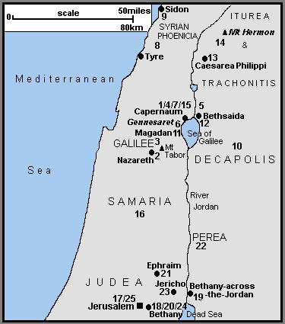

THIRD PREACHING TOUR OF GALILEE

[1] Jesus travels from Capernaum to "his own native town" of Nazareth ( Mark 6:1)

[2] In Nazareth, he is rejected for a second time (Matthew 13:54; Mark 6:1)

[3] He continues through Galilee (Matthew 13:58; Mark 6:6) and sends out the twelve apostles to preach the Gospel (Matthew 10:5; Mark 6:7; Luke 9:1)

[4] The Twelve return to Capernaum from their mission (Mark 6:30, Luke 9:10)

[5] From Capernaum, they go off by boat with Jesus to a quiet place (Mark 6:32) near Bethsaida (Luke 9:10). Here he feeds the 5,000 (Matthew 14:14; Mark 6:33; Luke 9:11; John 6:5)

[6] The disciples return across the Sea of Galilee (Matthew 14:22; Mark 6:45), Jesus walking on the water to join them (Matthew 14:25; Mark 6:48; John 6:19). They land near the Plain of Gennesaret and Jesus heals many people there (Matthew 14:34; Mark 6:53)

[7] From Gennesaret they make their way back to Capernaum (John 6:24) and Jesus teaches about the Bread of Life (John 6:26)

JESUS PREACHES AND HEALS IN SYRIAN-PHOENICIA, ITUREA and TRACHONITIS, THE DECAPOLIS

[8] Jesus retires from Galilee to the region of Tyre and Sidon in Syrian-Phoenicia (Matthew 15:21; Mark 7:24) where he heals the daughter of the Gentile Syrophoenician woman (Matthew 15:22; Mark 7:25).

[9] He leaves Syrian-Phoenicia via Sidon for Galilee (Matthew 15:29) but travels through the Decapolis (Mark 7:31).

[10] In the Decapolis he heals the deaf and mute man (Mark 7:32) and feeds the 4,000 (Matthew 15:32; Mark 8:1)

[11] Reaching the Sea of Galilee, he crosses by boat to the Magadan/Dalmanutha region (Matthew 15:39; Mk 8:10). There the Pharisees and Sadducees ask for a sign from heaven (Matthew 16:1; Mark 8:11)

[12] Continuing on to Bethsaida, a blind man is healed (Mark 8:22)

[13] Jesus now travels from Galilee, north to Caesarea Philippi in Iturea and Trachonitis, where Peter confesses that Jesus is the Christ (Matthew 16:13; Mark 8:27)

[14] Continuing on from Caesarea Philippi possibly further north towards Mount Hermon, three of the disciples see Jesus Transfigured in the presence of Elijah and Moses (Matthew 17:1; Mark 9:2; Luke 9:28). On his return, Jesus heals the boy with epilepsy (Matthew 17:14; Mark 9:14; Luke 9:37). Other traditions place the Transfiguration to the south, on Mount Tabor. The epileptic boy would then have been healed in the Galilee area.

[15] In Galilee (Matthew 17:22; Mark 9:30) in Capernaum (Mark 9:33), Jesus pays the Temple Tax with a fish! (Matthew 17:24). Then to avoid the dangers in Judea, he remains in Galilee (John 7:1)

LATER MINISTRY IN JUDEA

[16] Jesus leaves Capernaum and Galilee for the last earthly time (Matthew 19:1; Mark 10:1) and heads for Jerusalem (Luke 9:51; John 7:10). Travelling by Samaria, he heals the ten lepers (Luke 17:11) but is rejected in a Samaritan village (Luke 9:52)

[17] Arriving in Jerusalem for the Feast of the Tabernacles in the Autumn of c AD29 (John 7:10), Jesus forgives the woman caught in adultery (John 8:2) and heals the blind man who is taken before the Sanhedrin (John 9:1)

[18] During his travels in Judea, Jesus visits Martha and Mary in Bethany (Luke 10:38), returning to Jerusalem for "Hanukkah", the Feast of Dedication in December c AD29 (John 10:22)

THE LAST FEW MONTHS - c AD30

[19] Jesus withdraws to Bethany-across-the-Jordan (or Bethabara "where John had first baptised"), and into the province of Perea, and stays for a while (John 10:40)

[20] Following the death of Lazarus, Jesus returns to Bethany near Jerusalem, and raises him (Lazarus) from the dead (John 11:1).

[21] Because of threats to his life, Jesus withdraws to Ephraim to the north of Jerusalem (John 11:54)
HIS MINISTRY IN PEREA (MODERN JORDAN)

[22] He then crosses the River Jordan and works in Perea (Matthew 19:1; Mark 10:1). There he blesses the little children (Matthew 19:13, Mark 10:13; Luke 18:15) and speaks to the rich young man (Matthew 19:16; Mark 10:17; Luke 18:18)

THE FINAL JOURNEY TO JERUSALEM

[23] Jesus now travels towards Jerusalem for the last time (Matthew 20:17; Mark 10:32; Luke 18:31). Passing through Jericho he heals one (or two) blind men (Matthew 20:29; Mark 10:46; Luke 18:35) and converts Zacchaeus the tax collector (Luke 19:1).

[24] Reaching Bethany (John 12:1) the home of Lazarus, Mary and Martha, Jesus is anointed by Mary either now (John 12:2), or later (Matthew 26:6; Mark 14:3) after his triumphal entry into Jerusalem (Matthew 21:1; Mark 11:1; Luke 19:29; John 12:12)

[25] During the Easter week, Jesus returns to Jerusalem each day after staying overnight in Bethany on the Mount of Olives (Matthew 21:17-18; Mark 11:11-12;19; Luke 21:37).

Map 5 - The Galilee Area where Jesus Preached and Healed During Much of His Three Year Ministry

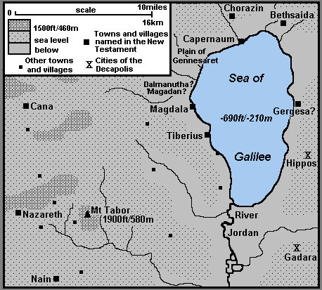

HIS TRAVELS and ACTS

Map 6 - The Miracles of Nature of Jesus

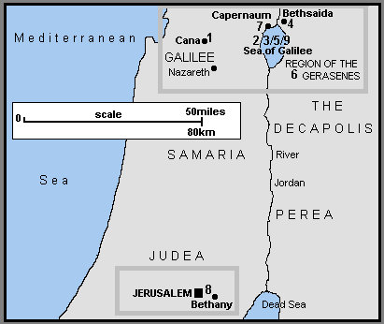

Year One - c AD27-28

[1] Cana - Water into wine

Year Two - c AD28-29

[2] Sea of Galilee - The first miraculous catch of fish

[3] Sea of Galilee - Calming the storm

Year Three - c AD29-30

[4] Near Bethsaida - Feeding the five thousand

[5] Sea of Galilee - Walking on water

[6] Region of the Gerasenes - Feeding the four thousand

[7] Capernaum - A fish pays the Temple tax!

The Last Week in Jerusalem - Spring c AD30

[8] Bethany to Jerusalem - The cursed fig-tree that withers way

After the Resurrection

[9] Sea of Galilee - The second miraculous catch of fish

Map 7 - The Healing Miracles of Jesus

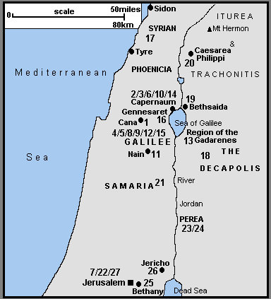

Year One - cAD27-28

[1] Cana - The officials' dying son

Year Two - c AD28-29

[2] Capernaum - The madman in the synagogue

[3] Capernaum - Peter's mother-in-law's fever: Jesus also heals many others that evening

[4] Galilee - Jesus continues preaching and healing

[5] Galilee - The leper

[6] Capernaum - The paralysed man

[7] Jerusalem - The invalid at the Pool of Bethesda

[8] Galilee - The man with the shrivelled hand

[9] Galilee - Jesus continues healing many

[10] Capernaum - The Roman centurion's servant

[11] Nain - Raising the widow of Nain's dead son

[12] Galilee - The dumb (and blind) man

[13] Region of the Gadarenes - The madman (or men) and the Gadarene swine (or pigs)

[14] Capernaum -The woman with the haemorrhage, and the raising of Jairus' daughter

[15] Galilee - Two blind men and the dumb man

Year Three - c AD29-30

[16] Gennesaret - Jesus heals the sick

[17] Tyre-Sidon Region - The sick daughter of the Syrophoenician woman

[18] The Decapolis - The deaf and dumb man

[19] Bethsaida - The blind man

[20] Caesarea Philippi - The epileptic boy

[21] Samaria - The ten lepers

[22] Jerusalem - The man born blind who goes before the Pharisees

The Last Months - c AD29-30

[23] Perea? - The crippled woman

[24] Perea? - The man with dropsy

[25] Bethany - Lazarus raised from the dead

[26] Jericho - The blind men near Jericho

The Last Week in Jerusalem - Spring c AD30

[27] Jerusalem - Healing the severed ear of the High Priest’s servant

Map 8 - The City of Jerusalem and its Eastern Approaches

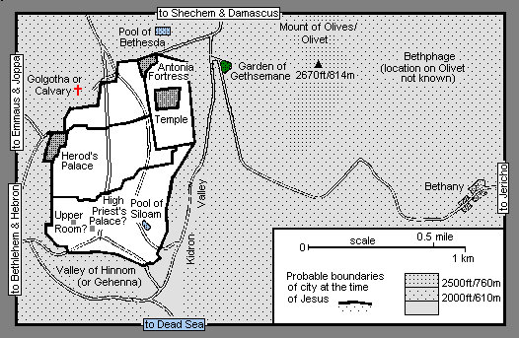

Map 9 - The Movements of Jesus During His Last Week in the Jerusalem Area Spring c AD30

THE SUNDAY BEFORE EASTER

[1] From the area of the two villages of Bethphage and Bethany, Jesus makes his triumphal entry into Jerusalem (Matthew 21:1; Mk 11:1; Lk 19:29; Jn 12:12).

Each night he returns to Bethany (Matthew 21:17-18; Mk 11:11-12, 19; Lk 21:37)

MONDAY TO THURSDAY

[2] Jesus concludes his confrontations with the religious establishment, often in Jerusalem and the Temple area. The plots to arrest and have him killed progress (Part 21). He describes the end-times and his return (Part 22); is possibly anointed at this time at Bethany (Part 23); and Judas Iscariot decides to betray him (Part 24)

THURSDAY EVENING AND NIGHT

[3] In the "Upper Room" (Matthew 26:17; Mark 14:12; Luke 22:7) Jesus holds the Last Supper (Matthew 26:20; Mark 14:17; Luke 22:14) and the apostles receive the bread and wine as his body and blood (Matthew 26:26; Mark 14:22; Luke 22:19)

[4] After the Last Supper, Jesus and his disciples cross the Kidron (or Cedron) Valley just outside Jerusalem, to the western edge of the Mount of Olives (Matthew 26:30; Mark 14:26; Luke 22:39; John 18:1). There in the Garden of Gethsemane as he prays, the disciples fall asleep (Matthew 26:36; Mark 14:32; Luke 22:40)

GOOD FRIDAY

[5] Jesus is arrested in the Garden of Gethsemane (Matthew 26:47; Mark 14:43; Luke 22:47; John 18:3) and taken to the High Priest's Palace (not the Temple) for questioning (Matthew 26:57; Mark 14:53; Luke 22:54; John 18:13). He then appears before members of the Council or Sanhedrin (Matthew 26:59; Mark 14:55; Luke 22:66)

[6] The members of the Sanhedrin escort Jesus to the Judgement Hall or Praetorium (the Roman governor's residence, probably in the Antonia Fortress) for interrogation and sentence by Pontius Pilate (Matthew 27:2,11; Mark 15:1; Luke 23:1; John 18:28)

[7] Pontius Pilate sends Jesus to Herod's Palace, the Jerusalem residence of the Jewish tetrarch of Galilee and Perea, Herod Antipas, for further questioning (Luke 23:6)

[8] On being taken back to Pontius Pilate (Luke 22:11) in the Antonia Fortress, Jesus is sentenced to death (Matthew 27:26; Mark 15:15; Luke 23:24; John 19:16). He is also flogged and tortured

[9] - Jesus is taken from the Judgement Hall to Golgotha or Calvary - the Place of the Skull (Matthew 27:31; Mark 15:20; Luke 23:26; John 19:16) where he is crucified (Matthew 27:35; Mark 15:24; Luke 23:33; John 19:18)

Place of the Skull - "Golgotha" in Aramaic and Hebrew. "Calvary" = Calvaria, or "skull" in Latin

Map 10 - The Appearances of Jesus to His Followers, including Stephen and Paul, after His Resurrection

There is no complete agreement by the various commentators on precisely how many different appearances Jesus made to his disciples

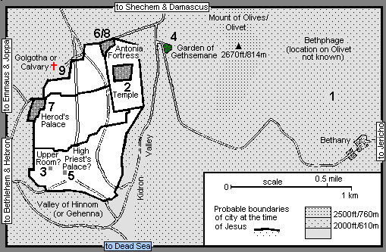

GOOD FRIDAY

[1] Golgotha or Calvary - Jesus is taken from the cross and placed in the garden tomb (Matthew 27:57; Mark 15:42; Luke 23:50; John 19:31)

EASTER SUNDAY IN AND AROUND JERUSALEM

[2] The Garden Tomb - Jesus appears to Mary Magdalene outside the tomb (Mark 16:9; John 20:11)

[3] The Garden Tomb - To Mary Magdalene and the other Mary (the mother of James the Younger and Joses (Mark 16:1) as they hurry from the tomb (Matthew 28:8)

[4] The Garden Tomb - To Peter (Luke 24:34; "Cephas" in 1 Corinthians 15:5)

[5] The Road to Emmaus - To two disciples on the Emmaus road later in the day (Mark 16:12; Luke 24:13)

[6] The Upper Room - To the apostles in a house in Jerusalem (Luke 24:36; John 20:19). Possibly the Upper Room where the Last Supper was held; Thomas was absent according to John 20:24.

A WEEK LATER

[7] The Upper Room - To the eleven apostles, including Thomas in a house; probably the same house as [6] (John 20:26; possibly Mark 16:14)

OVER THE NEXT WEEKS IN GALILEE

[8] The apostles go to Galilee (Matthew 28:16a); there Jesus appears to seven of them fishing on the Sea of Galilee (John 21:1)

[9] Jesus appears to the apostles on a mountain and gives his great commission to preach the Gospel to the world (Matthew 28:16b)

[10] More than 500 disciples in Galilee (1 Corinthians 15:6)

[11] To James, his brother (1 Corinthians 15:7)

ASCENSION DAY NEAR JERUSALEM

[12] To the apostles on the Mount of Olives (Olivet), near Bethany, as he ascends to Heaven (Mark 24:50, Acts 1:12)

AFTER HIS ASCENSION

[13] To Stephen as he is stoned to death in Jerusalem (Acts 7:55)

[14] To Paul on the road to Damascus (Acts 9:3; 26:13; 1 Corinthians 15:8)

[15] To John in a vision on the island of Patmos (Revelation 1:10)

Map 11 - Locations where the Original Apostles Preached the Gospel of Jesus Christ According to Various Ancient traditions

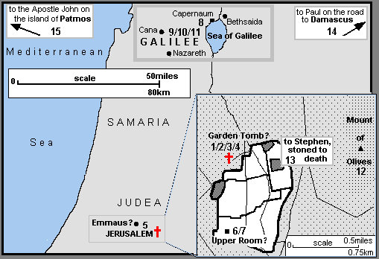

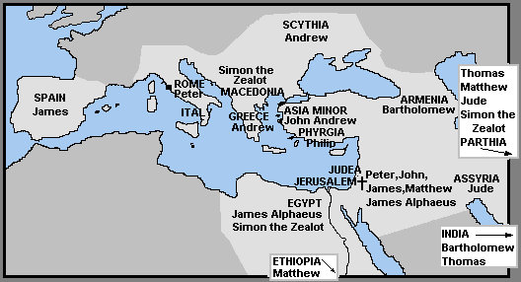

OUTLINE OF THE STORY OF JESUS USING MAPS

From J B Phillips’ Translation of the New Testament

