More Comfortable in a Saddle than a Pew!

Reaching out to those people who feel far more comfortable in a saddle than a pew.

Some people in Texas were having trouble with all those shalls and shall nots in the 10 Commandments. Folks there just aren't used to talking in those terms. So, some folks in east Texas got together and translated the "King James" into the "King Ranch" language:

Ten Commandments, Cowboy Style.
Cowboy's Ten Commandments posted on the wall at Cross Trails Church in Fairlie, TX

(1) Just one God.
(2) Honor yer Ma & Pa.
(3) No telling tales or gossipin'.
(4) Git yourself to Sunday meeting.
(5) Put nothin' before God.
(6) No foolin' around with another fellow's gal.
(7) No killin'.
(8) Watch yer mouth.
(9) Don't take what ain't yers.
(10) Don't be hankerin' for yer buddy's stuff.

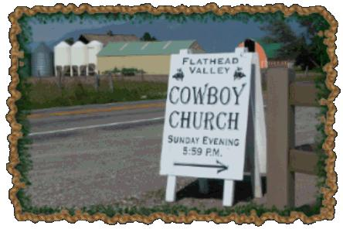

This is cowboy church — straight-shooter, sinner-saved-by-grace theology throwing a rope out to the lost, the lonely and those who long for an unvarnished faith.

No fancy duds. No politicized preaching.
No denominational hair-splitting.
It's come as you are, in spirit, spurs and Stetsons.
Its bucking bulls and plumbing Bibles in a dusty arena or dropping a hard-won dollar in a boot on the back table after a punchy sermon.

Fundamentally, it's an attitude, whether you ride a bronc or a computer keyboard.

What is church really?

A transmission vehicle to let people hear about the saving grace of Jesus.

But it would be really great if the church would practice SOUL-WINNING to the spiritually saved!

