Do You Know How The 13 Apostles Died?

1 | 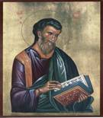 |  |  | Matthew  Suffered martyrdom in Ethiopia, killed by a sword wound.
2 | 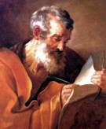 |  |  | Mark  Died in Alexandria, Egypt, after being dragged by horses through the streets until he was dead.
3 | 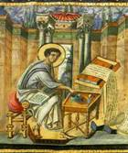 |  |  | Luke  Was hanged in Greece as a result of his tremendous preaching to the lost.
4 | 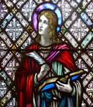 |  |  | John  Faced martyrdom when he was boiled in huge basin of boiling oil during a wave of persecution in Rome. However, he was miraculously delivered from death. John was then sentenced to the mines on the prison island of Patmos. He wrote his prophetic Book of Revelation on Patmos. The apostle John was later freed and returned to serve as Bishop of Edessa in modern Turkey. He died as an old man, the only apostle to die peacefully.
5 | 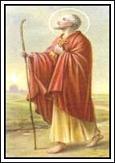 |  |  | Peter  He was crucified upside down on an x-shaped cross. According to church tradition it was because he told his tormentors that he  felt unworthy to die in the same way that Jesus Christ had died.
6 |  | 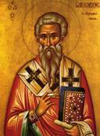 | James the Just  The leader of the church in Jerusalem, was thrown over a hundred feet down from the southeast pinnacle of the Temple when he refused to deny his faith in Christ. When they discovered that he survived the fall, his enemies beat James to death with a fuller's club.  * This was the same pinnacle where Satan had taken Jesus during the Temptation.
7 |  | 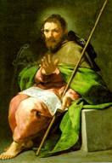 | James the Great  Son of Zebedee, was a fisherman by trade when Jesus called him to a lifetime of ministry. As a strong leader of the church, James was ultimately beheaded at Jerusalem. The Roman officer who guarded James watched amazed as James defended his faith at his trial. Later, the officer walked beside James to the place of execution. Overcome by conviction, he declared his new faith to the judge and knelt beside James to accept beheading as a Christian.
8 |  | 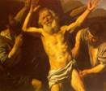 | Bartholomew  Also known as Nathaniel, was a missionary to Asia. He witnessed for our Lord in present day Turkey. Bartholomew was martyred for his preaching in Armenia where he was flayed to death by a whip.
9 |  | 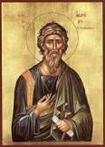 | Andrew  Was crucified on an x-shaped cross in Parts, Greece. After being whipped severely by seven soldiers they tied his body to the cross with cords to prolong his agony. His followers reported that, when he was led toward the cross, Andrew saluted it in these words: 'I have long desired and expected this happy hour. The cross has been consecrated by the body of Christ hanging on it.' He continued to preach to his tormentors for two days until he expired.
10 |  | 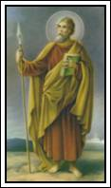 | Thomas  Was stabbed with a spear in India during one of his missionary trips to establish the church in the sub-continent.

11 | 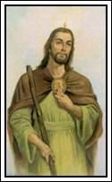 | Jude  Was killed with arrows when he refused to deny his faith in Christ.
12 | 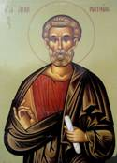 | Matthias  The apostle chosen to replace the traitor Judas Iscariot, was stoned and then beheaded.
13 | 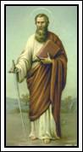 | Paul  Was tortured and then beheaded by the evil Emperor Nero at Rome in A.D. 67. Paul endured a lengthy imprisonment, which allowed him to write his many epistles to the churches he had formed throughout the Roman Empire. These letters, which taught many of the foundational doctrines of Christianity, form a large portion of the New Testament. Christ gave Paul the dispensation of Grace.

This is a reminder to us that our sufferings here are indeed minor compared to the intense persecution and cold cruelty faced by the apostles (and many disciples) during their time for the sake of the Faith.

