The human body has many members, yet each one has a unique role to play. The health and welfare of the body depend on the proper functioning of each member. That is how it is in the body of Christ.

God's Seven Spiritual Gifts

In God's great gift of salvation, we have a number of benefits and responsibilities. Gifts of the Spirit are benefits to each believer [one gift per believer], but they come with responsibilities.

There are two Greek words that are primarily used to describe the gifts of the Spirit. Pneumatika refers to their source, the Holy Spirit (pneuma) of God, and charismata refers to the fact that they are granted as an act of God's grace (charis). Since they are given by grace, we are reminded that they are not based on our worthiness or personal abilities, but on God's sovereign choice. Since they are given by the Spirit of God, they are a part of the new life granted to us in Christ (and may be drastically different from our perceived capabilities or desires prior to salvation).

See Romans 12:6-8 [gifts], Ephesians 4:11 and 1 Corinthians 12:28 [ministries], 1 Corinthians 12:6-10 [effects].
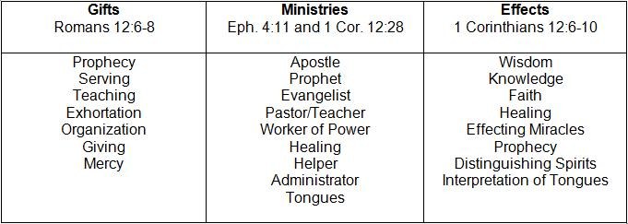
(Note: Different Gifts applied to different Ministries produce different Effects [results].)

Serving through Spiritual Gifts (Romans 12:3-8)

Paul speaks through the grace that was given to him as an apostle of the Lord Jesus. He is going to deal with various forms of straight and crooked thinking.

First he says that there is nothing in the gospel that would encourage anyone to have a superiority complex. He urges us to be humble in exercising our gifts. We should never have exaggerated ideas of our own importance. Neither should we be envious of others. Rather, we should realize that each person is unique and that we all have an important function to perform for our Lord. We should be happy with the place God has dealt to us in the Body, and we should seek to exercise our gifts with all the strength that God supplies.

The human body has many members, yet each one has a unique role to play. The health and welfare of the body depend on the proper functioning of each member.

That is how it is in the body of Christ. There is unity (one body), diversity (many), and interdependency (members of one another). Any gifts we have are not for selfish use or display but for the good of the body. No gift is self-sufficient and none is unnecessary. When we realize all this, we are thinking soberly.

Our gifts differ according to the grace that is given to us. In other words, God's grace deals out differing gifts to different people. And God gives the necessary strength or ability to use whatever gifts we have. So we are responsible to use these God-given abilities as good stewards.

The following is by Dr. Robert Jeffress, First Baptist Church of Dallas.

Spiritual gift – One per Christian. God's spiritual gift gives one the desire and power to achieve His purpose. Gifts help perfect the body of Christ. Exercising our gift causes us joy.

Prophecy – convict people of sin – Peter at Pentecost (Acts 2:1-47)
Serving – meeting practical needs of others – Mary and Martha (Luke 10:38-41)
Teaching – ability to present and clarify biblical truth -- pastors
Exhortation – comes along aside another Christian to help solve their problems using the Word
Giving – desire and ability to use person assets to further the cause of Christ
Lead – coordinating activities of others to achieve a common goal
Mercy – identify with and comfort those who are hurting

Seven Christians around a dinner table – hostess walks in with a dessert tray and spills the tray.

