Understanding Your
Hope of Glory

Course Outline

I. God’s Word

A. God’s Word is The Only Authoritative Source of Truth p 2

B. All Scripture is Inspired by God p 3

C. Scripture Exhorts Us to Rightly Divide The Word of Truth p 3

D. All the Facts Concerning a Matter Are Not Summed-Up in One Place in Scripture p 5

E. The Bible Code p 6

II. The Trinity – The Starting Point p 12

III. Biblical Trichotomies

A. The Make-Up of Man p 13

B. The Salvation of Man – A Decision and a Process p 14

C. Salvation of one’s Spirit vs. Salvation of one’s Soul p 15

D. The Offices of Christ – How They Relate to Man’s Salvation p 16

E. The Kingdom of God p 17

IV. Diagrams, Maps, Charts p 18

I. GOD’S WORD

A. God’s Word is the Only Authoritative Source of Truth

John 8:31-32 “Jesus was therefore saying to those Jews who had believed Him, ‘If you continue in My word, then you are truly disciples of Mine, And you shall know the truth, and the truth shall make you free.’”

Knowing the truth and being made free by it is conditioned upon continuing (NASV) or abiding (KJV) in God’s Word in the manner of a disciple. The CIA Headquarters has inscribed high upon one of its foyer walls, “You shall know the truth, and the truth shall make you free.” But according to Jesus, a man will not automatically come to know the truth simply because he exists or even because he wants to know it. The condition for knowing truth, according to Jesus, is continuing to learn and receive God’s Word as the only authoritative source of truth. The more truth we see and know in God’s Word, the freer we will become to act in accord with it and line up our whole lives with reality.

John 17:17 “Sanctify them in the truth; Thy word is truth.”

John 14:6 “Jesus said to him, ‘I am the way, and the truth, and the life. . .’”

John 1:1 “In the beginning was the Word, and the Word was with God, and the Word was God.”

John 1:14 “And the Word became flesh, and dwelt among us, . . .full of grace and truth.”

Romans 12:2 “And do not be conformed to this world, but be transformed by the renewing of your mind (through the Word), that you may prove what the will of God is, that which is good and acceptable and perfect.” The truth will set us free to live out God’s will, which is freedom indeed.

John 8:36 “So if the Son makes you free, you will be free indeed.”

Acts 17:11 “Now these were more noble-minded than those in Thessalonica, for they received the word with great eagerness, examining the Scriptures daily, to see whether these things were so.”

Noble-mindedness towards God’s Word consists of two things:

- Receiving it with great eagerness

2. Examining it diligently to prove out for ourselves that this is indeed what it says.
This attitude presupposes an acceptance of the fact that the scriptures are the authoritative source of Truth and that we are individually responsible before God to know what they say.
(Return)

B. All Scripture is Inspired by God

(The following statements apply to the original languages and manuscripts of the Bible. Translations from the originals sometimes contain errors and inaccurate interpretations. Therefore, at times, we have to examine carefully the original words in order to be sure of God’s intent and meaning in a passage, especially when we are seeking to establish doctrine.)

2 Timothy 3:16-17 “All Scripture is inspired (God-breathed) by God and profitable for teaching, for reproof, for correction, for training in righteousness; so that the man of God may be adequate, equipped for every good work.”

All Scripture, according to Scripture itself, is God-breathed (Gr. Theopneustos theh’-o-nyoo-stos), which means that God is the Author, that He produced it by His creative breath; thus it is not an ordinary book, but a supernatural and miraculous book, unlike any other.

2 Peter 1:21 tells us how this inspiration occurred: “. . . for no prophecy was ever made by an act of human will, but men moved by the Holy Spirit spoke from God.” The word “moved” could be translated “carried” or “borne” indicating that man’s will did not originate Scripture. However, men were still involved, as the Holy Spirit bore them along, keeping them from writing error and causing them to write God’s Word to us.

Jesus’ statements about Scripture show us that He believed it to be inspired by God and authoritative. Matthew 5:18 records the words of Jesus: “For truly I say to you, until heaven and earth pass away, not the smallest letter or stroke (one jot or one tittle – KJV) shall pass away from the Law, until all is accomplished.” John 10:35 tells us that Jesus said, “. . . the Scripture cannot be broken.” Jesus used Scripture to refute Satan when tempted in the wilderness. He referenced Scripture to answer men’s questions, and he spoke of Biblical characters and their works and words as true and authoritative examples from Scripture.

Psalm 12:6: “The words of the Lord are pure words; As silver tried in a furnace of the earth, refined (“purified” – KJV) seven times.” (The number seven in the Bible stands for spiritual completion or perfection.)

The infallibility and inerrancy of Scripture extends to every word and every letter, not just the main ideas. In recent years, the coming to light of The Bible Code and the expanding revelation of its contents, through the advent of the computer, is just one more proof for us that God put every letter of His Word in place. If this were not true, it would be impossible to find the thousands of hidden messages encoded in the original manuscripts.

The main point in reviewing this concept is to stress that we must be aware as we look at Scripture that God could have said something another way or used different words, but He chose to use these particular words and had a particular reason for doing so
(Return)

C. Scripture Exhorts Us to Rightly Divide the Word of Truth

2 Timothy 2:15: “Study to show thyself approved of God, a workman that needeth not to be ashamed, rightly dividing the word of truth.” (KJV)

NASV: “Be diligent to present yourself approved to God as a workman who does not need to be ashamed, handling accurately the word of truth.”

NIV: “Do your best to present yourself to God as one approved, a workman who does not need to be ashamed and who handles correctly the word of truth.”

God’s Word calls the one who is a student of the Word a workman. It says that at some point (ultimately at the Judgment Seat of Christ), we will be called on to present ourselves to God for approval concerning His Word which He has given us. At that time, we will need to show that we were handling accurately or correctly His Word. The KJV catches the proper sense of the idea of “handling correctly” when it says that we should “rightly divide” it. This is because there are many categories of truth that have distinct divisions, such as “Humanity” which is divided into three classes in God’s Word—Jews, Gentiles, and the Church. See 1 Corinthians 10:32: “Give no offense either to Jews or to Greeks or to the church of God.” While the word of truth is for all of us, in order for us to learn from it and apply its principles, it is not to all of us all the time. We cannot take certain promises that are for Israel, for instance, and apply them to the church. We can create much confusion if we lump the various aspects and parts of a category of truth all into a single grouping.

Some categories of things in the Bible which need to be separated out or divided are the following:

1. The make-up of man (Body, Soul, and Spirit)

2. The offices of Christ (Prophet, Priest, and King). All of these titles or offices belong to Christ, but He does not hold them all at the same time. They come in succession.

3. The Kingdom of God (There are three reflections of the Kingdom of God, one for each Person of the Godhead.)

4. The Ages (Creative, Anti –Diluvian, Law, Church, Kingdom, Perfect)

5. The Judgments (Judgment Seat of Christ, Sheep and Goat, Great White Throne)

6. The Resurrections (First Fruits, The Rapture, Tribulation Saints, 1000 Years Later)

7. The Scripture (Milk and Meat)

8. Dispensations (Innocence, Conscience, Government, Law, and Grace)

9. The People of God (Israel and the Church)

10 .The Gospel (It is all Good News, but the Scripture speaks of The Gospel of the Kingdom, The Gospel of Grace, The Gospel of the Glory of Christ, The ‘My Gospel’ of Paul, The Everlasting Gospel, and it is emphasizing something different by calling it something different.)

11. The Testaments (Old and New)
(Return)

D. All of the Facts Concerning a Matter Are Not Summed-Up in One Place in Scripture!
God Does Not Set Forth His Doctrines all at Once!
Why is This So?

Proverbs 25:2 “It is the glory of God to conceal a matter, But the glory of kings is to search out a matter.”

God says it is His glory to conceal a matter. He loves to hide things, especially meaningful treasures of His wisdom. He wants to see who is interested enough in Him to search out His knowledge, wisdom, and understanding. Who cares enough about Him to dig deep into the Word and look in many different places, searching until a special truth becomes clear? God says these are the kings, and they will experience glory as they pursue truth about a matter and discover it buried within the pages of God’s Word.

God says that He has given His Word to us in a particular way. Isaiah 28:10 and 13 say, “So the word of the Lord to them will be, Order on order, order on order, Line on line, line on line, a little here, a little there, . . . .”

We are to be kings and search for that which He has delighted to hide, so that He can delight us in discovering it. In 1 Peter 2:9 Peter is speaking to the church when he writes, “For you are a chosen race, a royal priesthood, a holy nation, a people for God’s own possession, that you may proclaim the excellencies of Him who has called you out of darkness into His marvelous light.”

Revelation 5:10 “And Thou hast made them to be a kingdom and priests to our God; and they will reign upon the earth.”

God says we are already a royal (kingly) priesthood, called to proclaim His Excellencies, and it is His plan that we shall reign with Him on the earth.

(Return)

E. The Bible Code

Does it Provide New Evidence that the
Bible is Supernatural in Origin?
By Dr. David Reagan
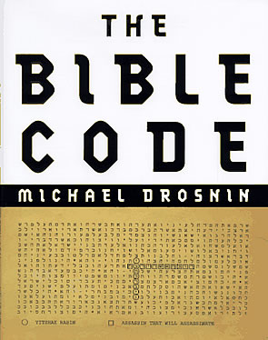

“The grass withers, the flower fades, but the word of our God stands forever.” – Isaiah 40:8
The evidence that the Bible is the Word of God is overwhelming to people of faith. We know that it is God’s Word first and foremost because of the transforming effect it has had upon our lives. We know first hand the truth of the statement that “the Word of God is living and active and sharper than any two-edged sword, and piercing as far as the division of soul and spirit, of both joints and marrow, and able to judge the thoughts and intentions of the heart” (Hebrews 4:12).

Bible Evidences

There are many other reasons we know the Bible is God’s Word. For example, there is the amazing fact of its internal harmony. The Bible is not one book. It is 66 different manuscripts written by 44 different people over a period of 1600 years. Yet, it harmonizes as if it were written by one person – which, of course, it was; for the overriding author who worked through human instruments was the Holy Spirit: “All Scripture is inspired by God . . .” (2 Timothy 3:16).

Further evidence of the Bible’s supernatural origin is to be found in the unique character of its biographies. The great men of God are revealed with unusual candor, warts and all. The histories are written in a blunt, revealing and unbiased way that is not characteristic of human writing. Just flip through the Old Testament histories and look at the judgments that are rendered regarding each king, and you will see what I am talking about.

Of course, one of the most convincing evidences of the Bible’s supernatural origin is the fact that it contains prophecies which have been fulfilled in history. The Bible is the only book in the world that serves as the basis of a religion that contains prophecies regarding the future. There are no prophecies in the Koran or in the Hindu Vedras or in the sayings of Confucius or Buddha.

Two other factors that establish the Bible as the Word of God are its unsurpassed wisdom and its advanced medical and scientific knowledge. The Bible’s moral and ethical content could not have originated from fallen human nature. Its precepts for daily living are wise beyond human wisdom. And long before science made the discoveries, the Bible contained the fundamental principles of hygiene (Leviticus 13-15) and revealed such things as the shape of the earth (Isaiah 40:22), the existence of ocean currents (psalm 8:8), the hydrological cycle of weather (Ecclesiastes 1:7, 11:3), and the second law of thermodynamics (Romans 8:20-21).

In the 19th Century a new science began to develop that would provide additional evidence of the Bible’s historical accuracy – the science of Archeology. The history of Biblical archeology is ironic for it has been dominated by skeptics who have been determined to disprove the Bible. Yet, every time they turn a spade of dirt, they find new evidence that verifies the Bible! They must be the most frustrated group of scientists on planet earth.

New Evidence

Now, many people are pointing to a new discovery called “The Bible Code,” claiming that it provides new scientific evidence that the Bible had to have a supernatural origin. Does it? Let’s take an in-depth look at it.

The first person we know of who detected a possible code in the Bible was a rabbi by the name of Rabbeynu Bachayah who lived in the 14th Century. He noted that words could be spelled out by skipping letters in equal distant spacing. His concept was picked up by another rabbi at the turn of this Century – a brilliant man by the name of Michael Dov Weissmandel who lived in Prague, Czechoslovakia. He spent years manually counting letters in his search for words and messages. He discovered, for example, that the word “Torah” is spelled out at the beginning of Genesis, Exodus, Numbers, and Deuteronomy when a skip sequence of 50 letters is used. He called this procedure “equidistant letter sequencing,” commonly referred to today as “ELS.”

In the mid-80’s a world famous mathematician in Israel heard about Weissmandel’s work and began to investigate it using computers. He was an Orthodox Jew by the name of Eliyahu Rips. He is the one who refined the Code and established its credibility. He did so through an amazing series of experiments.

Fascinating Experiments

He and two of his mathematical colleagues decided to run the Code on the book of Genesis to see if they could find three hundred common word associations like husband and wife, hammer and anvil, and tree and leaf. To their amazement, all three hundred were found in the 78,064 characters of Genesis. They wrote up this experiment and published it in a European statistical journal in 1988. They concluded that there is definitely a code in Genesis and that it could not exist by coincidence. In fact, they calculated that the odds of it appearing by coincidence were one in fifty-quadrillion.

Their next experiment was even more amazing. They went to a Jewish encyclopedia and selected the 34 greatest Torah sages (scholars) in Jewish history. They then fed their names into the computer to see if the Code could find them in the book of Genesis. All 34 were found, and in the immediate vicinity of each name was either the date of the person’s birth or death. They went back to the encyclopedia and selected 32 more names. They too were found in the book of Genesis a total of 66 names of Torah sages! This research was published in a journal of statistical science here in the United States in 1994. One reviewer concluded that the odds of the names appearing by chance was one in two and a half billion!

To make certain their results were not mere chance, Rips and his team ran the same code searches in other Hebrew documents, including a Hebrew version of Tolstoy’s War and Peace. The results were totally non-significant.

The editor of the American journal, Robert Kass, wrote:

“Our referees [scientists who reviewed the paper before publication] were baffled. Their prior beliefs made them think the book of Genesis could not possibly contain meaningful references to modern-day individuals. Yet, when the authors carried out additional analyses and checks, the effect persisted. The paper is thus offered to Statistical Science readers as a challenging puzzle.”

The research was checked and confirmed by Dr. David Kazhdan, chairman of the Harvard mathematics department and by Harold Gans, a senior code specialist with the U.S. Army. Both concluded that the Torah Code actually exists and that it could not have occurred by chance or by human design.

The Code Goes Public

Until this year few people outside a small circle of mathematicians, Orthodox Jews, and Evangelical Christians knew anything about the Code. What brought it to widespread public attention was the publication of a book by Michael Drosnin called The Bible Code (Simon & Schuster, new York, 1997).

Drosnin is an agnostic Jew who lives in New York City and makes his living as an investigative reporter. He is best known as a biographer of Howard Hughes.

In 1992 Drosnin was in Israel on an assignment when he heard about the Code. He decided to investigate the matter, with the thought in mind of writing an article to debunk it. But when Eliyahu Rips began to show him all that he had uncovered, including a prophecy that gave the exact date that the Gulf War began in 1991, Drosnin’s skepticism turned to curiosity. He got a copy of the Code’s software and took it back to New York with him. He began experimenting with the Code, and in the process he discovered that the name of Yitzhak Rabin appears only once, at an ELS of 4,772 between chapters 2 and 24 of Deuteronomy. Crossing Rabin’s name he found the phrase, “Assassin that will assassinate.”

Drosnin was so disturbed by this discovery that he flew to Israel and hand delivered a warning letter to one of Rabin’s best friends, asking him to deliver it to the Prime Minister. That was in September of 1994. Rabin read the letter and shrugged his shoulders. “I am not a mystic,” he said. Fourteen months later, in November 1995, Rabin was assassinated.

Fascinating Discoveries

Drosnin’s book is filled with amazing findings that he and others have made with the Code. For example, they have found the names of hundreds of world renowned historical figures, and adjacent to their names they have discovered words relevant to their lives. Next to Napoleon’s name are the words “France,” “Waterloo,” and “Elba.” Surrounding Shakespeare’s name are the words: “presented on stage” – “Hamlet” – “Macbeth.”

Every major advance in modern technology appears to be encoded, from the light bulb to the airplane. And the inventor’s name appears adjacent to the invention.

A leading mathematician at Yale whose last name is Piatetski-Shapiro performed tests of the Code and was amazed to find “Hitler” and “Nazi” encoded together with the word “slaughter.” He found “Eichmann” encoded with the words “the ovens” and “extermination.” Even the gas used to kill the Jews, “Zyklon B,” was encoded with Eichmann’s name. The Yale professor concluded, “There is no way within the known laws of mathematics to explain seeing the future . . . What we’re talking about here is some intelligence that stands outside . . . I think the only answer is that God exists.”

Amazingly, Drosnin has avoided that conclusion. He says, “I am persuaded only that no human could have encoded the Bible in this way. We have the first scientific proof that some intelligence outside our own does exist, or at least did exist at the time the Bible was written . . . The Bible Code demands that we accept what the Bible itself can only ask us to believe – that we are not alone.” A very New Age, Star Wars type of conclusion, to say the least.

The most important future event that Drosnin feels he has found with the Code is a world war in which nuclear weapons will be used. He feels this is more of a warning than a prediction, and this leads to the incredible conclusion of his book: “[The Code] is not a promise of divine salvation. It is not a threat of inevitable doom. It is just information. The message of the Bible code is that we can save ourselves” (emphasis added).

That conclusion made me want to scream: “What spiritual blindness!” It made me realize that Drosnin is like a man who has discovered the magnetic strip that is embedded in every $100 bill. That strip can be seen only if the bill is held up to the light. It certifies that the bill is authentic.

The man is so excited by his discovery that he spends all his time holding the bill up to the light, showing everyone the strip. He is so fascinated by the strip and so obsessed with it, that he never notices the large picture of Ben Franklin on the face of the bill.

That’s where Drosnin is with the Bible Code. He is so fixated on something that authenticates the Bible as the Word of God that he cannot see the very clear surface picture that the Bible presents of the Messiah, Jesus of Nazareth. Nor can he hear the surface message of the Bible that is calling him to repent of his sins and receive Jesus as his Lord and Savior. If the Bible teaches anything, it teaches that we cannot save ourselves!

Is it Valid?

But does the Code really provide new evidence that the Bible is the Word of God? Is it authentic or is it a sham?

The harshest critic of the Code is Dr. Ronald S. Hendel who teaches at SMU. He dismisses it as a sham and a hoax. He does so by quibbling with some of Drosnin’s translations. But mainly, he simply asserts that the Masoretic text used by Rips and Drosnin (often called the textus receptus) is just one of many Hebrew texts, that it differs from other texts, and that it is full of scribal errors.

But keep in mind that Hendel’s basic viewpoint is that of a classic modern day liberal who denies the verbal inspiration of the Scriptures and argues that the Bible is really a product of Man’s search for God and therefore is full of myth, legend and superstition. It is only natural that he should react with vehemence to any evidence that points to a supernatural origin of the Bible. But the important thing to keep in mind regarding his criticism is that he simply has no answer for the fact that the Code works with the Masoretic text and does not work with other texts.

Another critic is Shlomo Sternberg who is both an Orthodox rabbi and a mathematician. He teaches at Harvard. His basic assertion is that “ELS codes can be found everywhere. In sufficiently long text, in any alphabetic language, one can always find hidden messages by the ELS method.” He then demonstrates his point by showing that he found the assassination of President Somoza of Nicaragua by using ELS to search the novel Moby Dick.

The only problem with Sternberg’s argument is that it ignores the overwhelming number of matches made in both of Rips’ experiments – matches that could not be duplicated in other documents. Rips has proved statistically that his finds are beyond the realm of coincidence, and Sternberg does not address that point.

But Sternberg does make a very good point when he attacks Drosnin for using the Code like a Ouija Board or a crystal ball to try to foretell the future. He points out that “this violates the explicit biblical prohibition against augury, necromancy and the like” (Deuteronomy 18:9-14).

Eliyahu Rips agrees with Sternberg on this point. He has also attacked Drosnin for using the Code like a tool of witchcraft: “All attempts to extract messages from Torah Codes or to make predictions based on them are futile and of no value. The only conclusion that can be drawn from the scientific research regarding the Torah Codes is that they exist and that they are not a mere coincidence.”

Some Conclusions

So where does this leave us? I can only speak for myself. Like Eliyahu Rips, I am convinced that the Code is legitimate. Because of that conclusion, I believe it is one more piece of evidence that substantiates the supernatural origin of the Bible.

I also believe it substantiates the verbal, word for word, inspiration of the Bible. Jesus Himself attested to verbal inspiration when He said, “Until heaven and earth pass away, not the smallest letter [jot] or stroke [tittle] shall pass away from the Law . . .” (Matthew 5:18). Modern day scholars mock the concept of verbal inspiration. And like Hendel, they also argue that even if it were true, all we have left are corrupted manuscripts. Well, I happen to believe that the same Holy Spirit who wrote the Bible is fully capable of preserving it from human corruption.

Despite my conclusion that the Code is legitimate, I want to speak a word of caution regarding it. I believe the Code poses a danger – the danger of Kabalism. This is the ancient Jewish mystical movement that has always argued that the true message of the Bible is hidden. They usually find its “true” message by spiritualizing the Scriptures to mean whatever they want them to mean.

The Code could easily be used for this purpose, and in the process it could produce some very weird messages. The reason this can so easily happen is because there are no vowels in the text of the Hebrew Scriptures. Thus, a series of five consonants could stand for as many as twenty or more words, depending on the vowels supplied by the reader. It is the context that determines the meaning of the word. And that is exactly the problem with the Code that makes it easily subject to abuse – namely, there is no context when using the Code.

Predicting the Future

I think it is interesting that the major future prophecy that Drosnin claims to have found with the Code is the prediction that there will be a World War III fought with nuclear weapons. He claims this information is encoded in the “Shema” in Deuteronomy 6:4-5.

Well, that is not new information. The book of Revelation makes it very clear that there is going to be a future world war of unparalleled proportions in which one-half of the population of the world will die. And I personally think that Revelation also makes it clear that this war will be fought with atomic weapons.

The point I want to drive home is that we do not need the Code to predict the future. The future course of world events is laid out for us in the surface message of the Bible in its end time prophecies. The Lord has told us all we need to know about the future in the surface message of the Bible.

Again, using the Code to try to predict future events will result in Satanic deceptions.

Some Further Evidence

I have saved the best for last. Further evidence of the validity of the Code has been produced by a Messianic Jew named Yacov Rambsel. In his newly released book, “Yeshua,” he reveals what he has discovered by exploring key Old Testaments passages using the ELS approach manually. His discoveries are nothing short of sensational.

In the most famous Messianic passage in the Bible, Isaiah 53, he found the following phrase encoded in verse 10 at a skip sequence of 20 letters: “Yeshua Shmi.” That phrase means “Yeshua is my name.” Think of it, the very name of the Messiah is encoded in the passage that speaks of His sacrifice for the sins of Mankind!

In like manner, Rambsel found the name of the Messiah in Daniel’s famous prophecy of the seventy weeks of years (Daniel 9:24-27). Encoded in verse 26, counting every 26th letter, is the name “Yeshua.”

In Leviticus 21:10-12 there is a passage regarding the rules of the priesthood and the sacrifices offered for the sins of the people. Yacov discovered that counting every third letter this passage spells out the phrase, “Hain dam Yeshua,” which means “Behold! The blood of Yeshua.”

Another Conclusion

Drosnin says he considers the Code to be a “time-lock” that has been waiting on the advent of the computer age. I think he is probably right in that conclusion.

But I think the timing of the Code’s revelation is significant in another respect. I see it as just one more sign of the soon return of the Lord. As that day approaches, God the Father is providing us with fresh evidence that the Bible is what it claims to be the Word of the one and only true God. The new revised Egyptian chronology which I discussed in our May issue provides fresh evidence that the Bible is trustworthy in its historical records. The Bible Code provides new evidence that it had a supernatural origin.

I believe the Lord is providing us with this fresh evidence to substantiate the Bible because His Son is about to return, and the Father does not wish that any should perish, but that all should come to repentance. I praise God for His mercy.

For further information on the Code and the evidences that the Bible is the Word of God, read the following books:

- The Signature of God by Grant Jeffrey. This is an outstanding book that presents a fascinating summary of a great host of evidence that the Bible came from God.

- Yeshua by Yacov Rambsel. Published by Frontier Press.

Both of these books should be available at your favorite Christian bookstore.

(Return)

II. The Trinity – The Starting Point

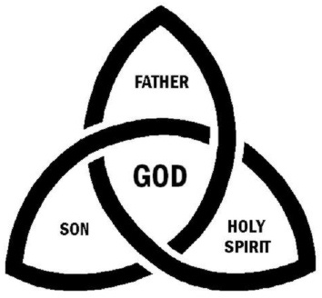

There is only one God, but in the unity of the Godhead, there are three eternal and coequal Persons, the same in substance but distinct in their forms of existence.

Then God said, “Let us make man in our image, according to our likeness;.(Genesis 1:26a).
In the above passage the word for God is Elohiym (Heb. Pronounced el’-o-heem, plural of Eloahh [God]), a fact which is reflected in the quotation where God refers to Himself as us and speaks of His image and likeness as our image. It indicates three or more. When we harmonize this fact with the remainder of scripture, we can see that it means exactly three and no more.

1. The Father is God. YHWH (Heb. Yood’-ha’-vav-ha’ or yah’-wa), The Self-Existent One.
- Scripture: John 6:27; Ephesians 4:6; Acts17:29.

2. Jesus Christ is God.
- Scripture: Hebrews 1:8; John 1:1; as compared to John 1:14; John 8:58.

3. The Holy Spirit is God.
- Scripture: Acts 5:3, 4.

Since Elohiym has made us in His image and likeness, it is logical that we should reflect the Trinity in our make-up. This is the first KEY to understanding man’s creation and redemption (salvation).

(Return)

III. Biblical Trichotomies

A. Make-Up of Man
(SPIRIT-SOUL-BODY)

- Scripture:
1 Thessalonians 5:23; Hebrews 4:12, 13; Genesis 1:27

Spirit: God Conscious
We communicate with God through our spirit (Romans 8:16).
Adam’s spirit dies (Genesis 2:17).
Death passed to all men (Romans 5:12).
They tried to cover themselves—inadequately (Genesis 3:6-7).
God’s provision (Genesis 3:21; Hebrews 9:22).

Soul or Life (Gr. Psuche): Self Conscious
Composed of: Mind, Will and Emotions

Body: World Conscious
Five senses: Sight, Hearing, Smell, Taste, Touch.

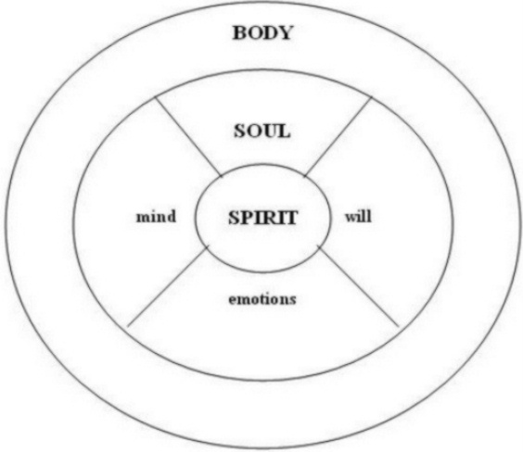

(Return)
B. The Salvation of Man
(SPIRIT–SOUL–BODY)

Salvation of the SPIRIT:

- Past tense salvation—Justification: The demands of the Law against us have been met by the blood of Christ. Christ has paid the penalty for our sins. “We have peace with God through our Lord Jesus Christ.”
- Saved from the penalty of sin—eternal separation from God—Lake of Fire.
- It is a free gift, not of works.
- Man’s spirit is regenerated (born again) when God’s Spirit enters and becomes one with man’s spirit.
- Happens immediately, the moment one believes in the Lord Jesus Christ. See Acts 16:30, 31.
- The believer is sealed by the Holy Spirit the moment he believes.
- The believer is made a child of God.
- Salvation of the spirit cannot be lost. Heaven is assured.
- “Qualifies” believer to run the race for the prize.

  - Scriptures: Ephesians 2:8, 9; Romans 4:5; Acts 16:30, 31; Acts 10:43, 44; Ephesians 1:13; 4:30; 2 Corinthians 1:21, 22; 5:5, 17

Salvation of the SOUL:

- Present tense salvation---presently in progress.
- Saved from the power (the downward pull) of Sin.
- Begins when one’s saved spirit initiates a surrender of self and a continuous faith.
- It is not a free gift, but is based on works of faith which are produced as we feed on the Word daily--live by faith--stay in fellowship with God--abide in Christ--walk in the Spirit.
- It is not assured—must be “worked out” over the lifetime of the believer. Philippians 2:12, 13.
- Will be determined at the Judgment Seat of Christ.
- The saved soul will be granted reward at the Judgment Seat of Christ.
- The soul not saved will suffer loss at the Judgment Seat of Christ—but not the loss of heaven.

- Scriptures: Matthew 11:28-30; James 1:18-21; 1 Peter 1:3-9, 13; Ezekiel 33:31; Matthew 16:24-27; Matthew 17:1-9; 2 Peter 1:16-21; 2 Peter 1:1-15, Daniel 7:13, 14; 2 Corinthians 5: 10, 11; 1 Corinthians 3: 10-15; 1 Corinthians 9:24-27; 1 Corinthians 10:1-12; Hebrews 12:1-3; 2 Timothy 2:1-13; Romans 5:1-5; 8-11, 16-18; Matthew 19:28, 29; Titus 3:5-8; 1 Timothy 6:9-12;17-19; Colossians 3:23-25; Colossians 1:15-19; Philippians 3:7-21

Salvation of the BODY:

- Future tense salvation.
- Saved from the presence of Sin.
- Happens in a moment of time—at the resurrection or rapture.

  - Scriptures: 1 Thessalonians 4:16, 17; Romans 8:23. (Return)
C. Salvation of one’s Spirit vs. Salvation of one’s Soul

SPIRIT | SOUL
1. Past tense salvation - Justification: The demands of the Law against us have been met by the blood of Christ. Christ has paid the penalty for our sins. “We have peace with God through our Lord Jesus Christ.” | 1. Present tense salvation---presently in progress.
2. Saved from the penalty of sin--eternal separation from God--Lake of fire. | 2. Being saved from the power (the downward pull) of Sin.
3. It is a free gift, not of works. Qualifies believer to run the race for the prize. | 3. Begins when one’s saved spirit initiates a surrender of self and a continuous faith.
4. Man’s spirit is regenerated (born again) when God’s Spirit enters and becomes one with man’s spirit. | 4. It is not a gift, but is based on works of faith which are produced as we live by faith—stay in fellowship with God—abide in Christ—walk in the Spirit.
5. Happens immediately, the moment one believes in the Lord Jesus Christ. See Acts 16:30-31. | 5. It is not assured—must be worked-out over the lifetime of the believer. Philippians 2:12-13
6. The believer is sealed by the Holy Spirit the moment he believes. | 6. Will be determined at the Judgment Seat of Christ.
7. The believer (saved spirit) is made a child of God. | 7. The saved soul will be granted reward at the Judgment Seat of Christ.
8. Salvation of the spirit can not be lost. Heaven is assured. | 8. The soul not saved will suffer loss at the Judgment Seat of Christ—but not the loss of heaven.
- Scriptures: Ephesians 2:8, 9; Romans 4:5; Acts16:30-31; Acts 10:43. 44; Ephesians 1:13 and 4:30; Titus 3:5 | - Scriptures: Matthew 11:28-30; James 1:18-21; 1 Peter 1:3-9; Matthew 16:24-27; Matthew 17:1-9; 2 Peter 1:16-21; Daniel 7:13, 14; 2 Corinthians 5: 10, 11; 1 Corinthians 3: 10-15; 1 Corinthians 9:24-27; 1 Corinthians 10:1-12; Hebrews 12:1-3; 2 Timothy 2:1-13; Romans 8:17; Matthew 19:28-29; Titus 3:5-8; 1 Timothy 6:9-12;17-19; Colossians 3:23-25; Romans 5:1-5; Colossians 1:15-19; Philippians 3:7-21

- See V. Diagrams, Maps, Graphs, ”Three Tenses of Salvation”
(Return)
D. The Offices of Christ
(PROPHET–PRIEST-KING)

As PROPHET Through this office our past tense salvation (of the Spirit) was completed.

- He prophesied by the Spirit and by the Word and by His walk.
- He was slain outside the city as prophets were.
- It was in his office of prophet that Jesus paid the penalty for our sins.
- This office is typified by the myrrh (an antiseptic gum resin used in burial) given by the wise men at His birth.

  - Scriptures: Deuteronomy 18:15, 18-19; Matthew 13:57; Matthew 21:11;
John 19:39

As PRIEST Through this office our present tense salvation (of the soul) is completed.

- He is presently interceding for us.
- His intercession depends on His own shed blood.
- His intercession is necessary for us to maintain fellowship with God (1 John 1:9)
- This office is typified by frankincense (a sweet smelling incense) given by the wise men at Christ’s birth.

  - Scriptures: Hebrews 10:12, 21, 22; 1 John 2:1; Hebrews 2:17; Hebrews 4:15, 16, 8:1, 9:11-15; 1 John 2:1, 1:9; Hebrews 12:24; John 15:1, 2; Hebrews 12:5, 6

As KING Through this office our future tense salvation (of the body) will be completed.

- This office begins after Christ finished His High Priestly duties.
- He will judge all Christians in Heaven (II Corinthians. 5:10).
- At this same time, God will be judging Israel in an earthly judgment through the “furnace of affliction” during the Tribulation Period (Isaiah. 31:9 and Zechariah 13:8, 9).
- He will judge the world at His Second Coming and will destroy worldly kingdoms and set up His own Kingdom (Daniel 2). All judgment is committed to the Son (John 5:22).
- He will reign as King over Israel according to the Davidic Covenant (2 Samuel 7:16, 22-29)
- He will reign as King over the entire earth and all nations. He will rule with a rod of iron (Psalms 2; Revelation 12:5). The overcomers will also rule with Him over the nations with a rod of iron (Revelation 2:26-27).
- This office is typified by the gold given by the wise men at Christ’s birth.

  - Scriptures: 2 Corinthians 4:4; Matthew 2:6; Revelation 19:11-16, 20:6; Isaiah 9:6, 7; Isaiah 11; Matthew 25: 31, 32; Zechariah 14:9; Psalms 89: 20-29, 35-37; Daniel. 2: 34-44; 2 Samuel 7:16, 23-29;John 5:22; Revelation 12:5; Revelation 2:26, 27

(Return)

E. The Kingdom of God
(FATHER-SON-HOLY SPIRIT)

The Kingdom of God the FATHER

- We enter the Kingdom of the Father by creation or birth.
- God the Father rules over all creation from a literal throne in the third heaven.
- In His Kingdom are all that have been created: planets, universes, angels, animals, insects, lost men, saved men. He sovereignly rules them all.

  - Scripture: Daniel 4:34, 35.

The Kingdom of God the SON

- This Kingdom is a future Kingdom. Christ will reign for 1000 years over the earth.
- This Kingdom was known in the Old Testament as the Messianic Kingdom. In the New Testament, it is known as the Kingdom of Heaven, The Kingdom of God, and the Millennial Kingdom.
- Entrance depends on having a saved soul—gaining reward at the Judgment Seat of Christ.
- It is associated with the “hope of glory,” which is to rule and reign with Christ for 1000 years. (Colossians 1:27; Romans 5:2)
- The hope of being able to enter this Kingdom is a great incentive to run the Christian race (Heb. 12:1) and to “press on toward the goal for the prize.”

  - Scripture: Luke 19:17-19; Gal. 5:19-21; Eph. 5:3-5; Dan. 2:44; Dan. 7:13, 14, 22; Isa. 9:6, 7; Isa. 32:1-4, 15-20; Zech. 14:3-9; Rev. 20:4-6; Isa. 11; 52; 54; 60; 62; 65; Isa. 17-25; Matt. 19:28-30; Hosea 6:1-3, 11; Zech. 8; 9:10; 13; Hosea 2:14-23; 3:4-5; 2 Sam. 7:16; Psalms 89:3, 4, 11-37; Heb. 12:28.
Jesus Uses Parables to Teach the Kingdom of Heaven: Heb. 2:3; Matt. 13:19, 24, 31, 33, 44, 45, 47; 20:1; 25:1, 14.

The Kingdom of God the HOLY SPIRIT

- We enter the Kingdom of God the Holy Spirit by faith at the moment of belief as the Holy Spirit enters the believer’s spirit.
- The Holy Spirit rules over the “new creation” with the believer’s permission.

  - Scripture: Romans 14:17-19; Romans 8:13, 14; Galatians. 5:16-18; Ephesians. 5:18-21, 25, 26.

(Return)

IV. Diagrams, Maps, Charts

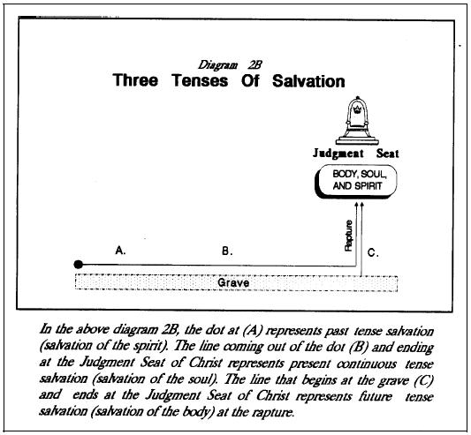
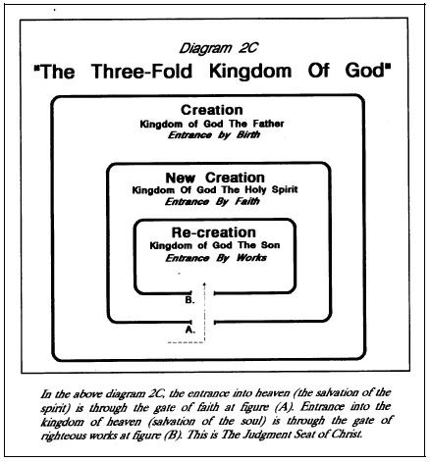

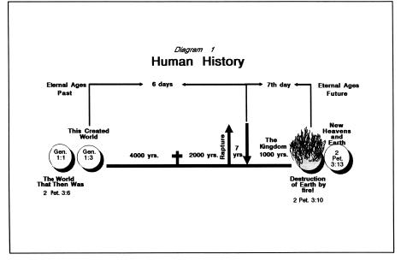
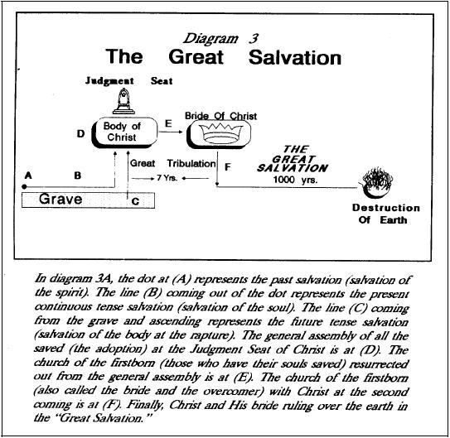

(Return)

