Jesus in all the books of the Bible
By Jesus Plus Nothing

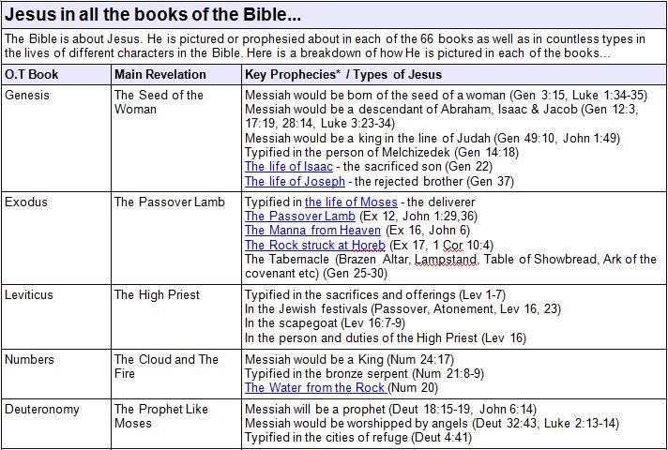
Scripture links:

Genesis: Gen. 3:15, Luke 1:34-35, Gen. 12:3, 17:19, 28:14, Luke 3:23-34, Gen. 49:20, John 1:49, Gen. 14:18, Gen. 22, Gen.37
Exodus: Ex. 12, John 1:29, 36, Ex. 16, John 6, Ex. 17, 1 Cor. 10:4, Gen. 25-30
Leviticus: Lev. 1-7, Lev. 16, 23, Lev. 16:7-9, Lev. 16
Numbers: Num. 24:17, 21:8-9, Num. 20
Deuteronomy: Deut.18:15-19, John 6:14, Deut. 32:43, Luke 2:13-14, Deut. 4:41
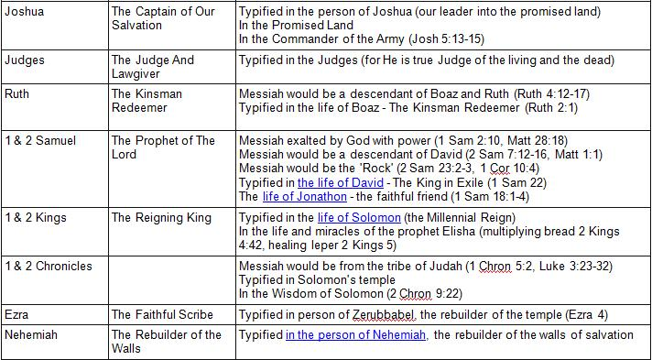
Joshua: Josh. 5:13-15
Ruth: Ruth 4:12-17, 2:1
1 & 2 Samuel: 1 Sam. 2:10, Matt. 28:18, 2 Sam. 23:2-3, 1 Cor. 10:4, 1 Sam. 22, 1 Sam. 18:1-4
1 & 2 Kings: 2 Kings 4:42, 2 Kings 5
1 & 2 Chronicles: 1 Chron. 5:2, Luke 3:23-32, 2 Chron. 9:22
Ezra: Ezra 4
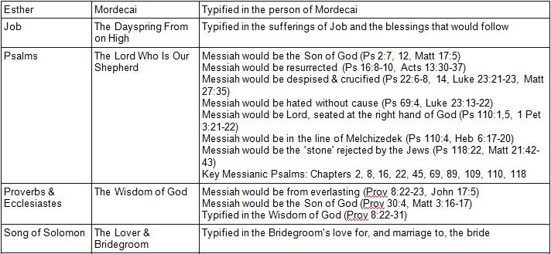
Psalms: Ps. 2:7, 12, Matt. 17:5, Ps. 16:8-10, Acts 13:30-37, Ps. 22:6-8, 14, Luke 23:21-23, Matt. 27:35, Ps. 69:4, Luke 23:13-22, Ps. 110:1, 5, 1 Pet. 3:21-22, Ps. 110:4, Heb. 6:17-20, Ps. 118:22, Matt. 21:42-43, Ps. 110:4, Heb. 6:17-20, Ps. 118:22, Matt. 21:42-43, Ps. 2; 8; 16; 22; 45; 69; 89; 109; 110; 118
Proverbs & Ecclesiastes: Prov. 8:22-23, John 17:5, Prov. 30:4, Matt. 3:16-17, Prov. 8:22-31
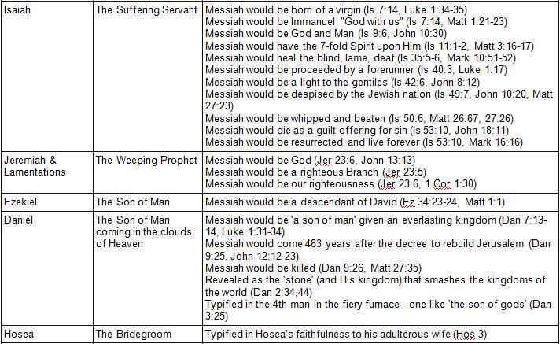
Isaiah: Isa. 7:14, Luke 1:35-36, Matt. 1:21-23; Isa. 9:6, John 10:30, Isa. 11:1-2, Matt. 3:16-17, Isa. 35:5-6, Mark 10:51-52, Isa. 40:3, Luke 1:17, Isa. 42:6, John 8:12, Isa. 49:7, John 10:20, Matt. 27:23, Isa. 50:6, Matt. 26:67; 27:26, Isa. 53:10, John 18:11, Mark 16:16
Jeremiah & Lamentations: Jer. 23:6, John 13:13, Jer. 23:5, 1 Cor. 1:30
Ezekiel: Eze. 34:23-24, Matt. 1:1
Daniel: Dan. 7:13-14, Luke 1:31-34, Dan. 9:25, John 12:12-23, Dan. 9:26, Matt. 27:35, Dan. 2:34, 44, Dan. 3:25
Hosea: Hos. 3:1-5
Joel: Joel 2:32, Rom. 10:12-13, Joel 2:28-32
Amos: Amos 8:9, Matt. 27:45-46
Jonah: Jon. 1:17, Matt. 12:40
Micah: Mic. 5:2, Matt. 2:1-2, Rev. 1-8
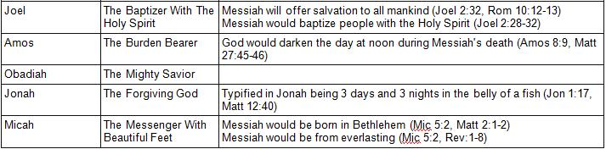
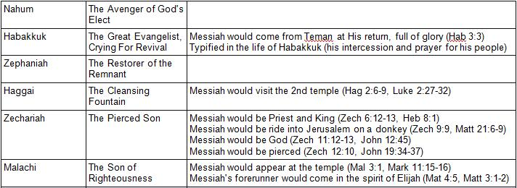
Habakkuk: Hab. 3:3
Haggai: Hag. 2:6-9, Luke 2:27-32
Zechariah: Zech. 6:12-13, Heb. 8:1, Zech. 9:9, Matt. 21:6-9, Zech. 11:12-13, John 12:45, Zech. 12:10, John 19:34-37
Malachi: Mal. 3:1, Mark 11:15-16, Matt. 4:5, Matt. 3:1-2
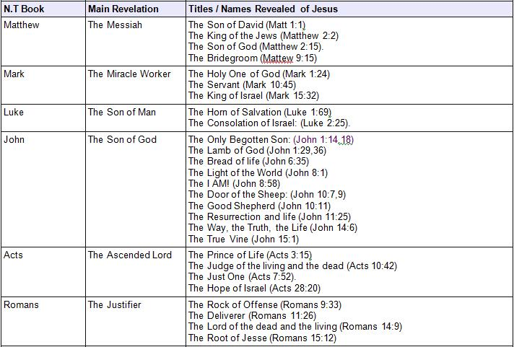
Matthew: Matt. 1:1, Matt. 2:2, Matt. 2:15, Matt. 9:15
Mark: Mark 1:24, Mark 10:45, Mark 15:32
Luke: Luke 1:69, Luke 2:25
John: John 1:14, 18, John 1:29,36, John 6:35, John 8:1, John 8:58, John 10:7,9, John 10:11, John 11:25, John 14:6, John 15:1
Acts: Acts 3:15, Acts 10:42, Acts 7:52, Acts 28:20
Romans: Rom. 9:33, Rom. 11:26, Rom. 14:9, Rom. 15:12
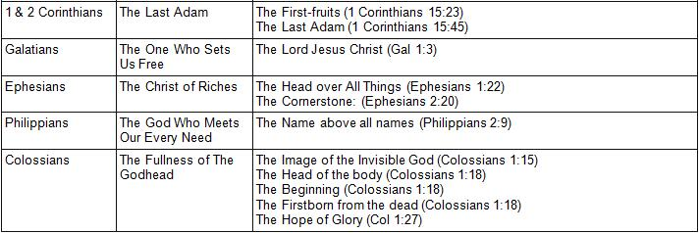
1 & 2 Corinthians: 1 Cor. 15:23, 1 Cor. 15:45
Galatians: Gal. 1:3
Ephesians: Eph. 1:22, Eph. 2:20
Philippians: Phil 2:9
Colossians: Col. 1:15, Col. 1:18. Col. 1:27
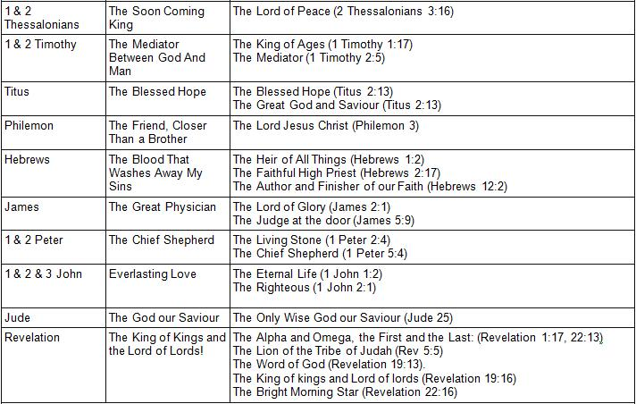
1 & 2 Thessalonians: 2 Thess. 3:16
1 & 2 Timothy: 1 Tim. 1:17, 1 Tim. 2:5
Titus: Titus 2:13
Philemon: Philemon 1:3
Hebrews: Heb. 1:2, Heb. 2:17, Heb. 12:2
James: James 2:1, James 5:9
1 & 2 Peter: 1 Peter 2:4, I Peter 5:4
1, 2 & 3 John: 1 John 1:2, 1 John 2:1
Jude: Jude 1:25
Revelation: Rev. 1:17, 22:13, Rev. 5:5, Rev. 19:13, Rev. 19:16, Rev. 22:16
~~~~~~~~~~~~~~~~~~~~~~~~~~~~~~~~~~~~~~~~~~~~~~~~~~~~~~~~~~~~~~~~~~~~~~~~~~~~~
* Prophecy Source: http://www.messiahrevealed.org/book-index.html

Jesus Plus Nothing - Jesus in all the books of the Bible

