The letters give a consecutive preview of the history of Christendom,
each church representing a distinct period.
The trend of conditions is downward.

Letters from Our Lord (Revelation 2; 3)
By Believers Bible Commentary

In Revelation 2; 3, we have individual letters addressed to the seven churches of Asia. The letters may be applied in at least three ways. First of all, they describe conditions that actually existed in the seven local churches at the time John was writing. Secondly, they give a view of Christendom on earth at any one time in its history. The features found in these letters have existed in part, at least, in every century since Pentecost. In this respect, the letters bear marked resemblances to the seven parables of Matthew 13. Finally, the letters give a consecutive preview of the history of Christendom, each church representing a distinct period. The general trend of conditions is downward. Many believe that the first three letters are consecutive and that the last four are concurrent, reaching to the time of the Rapture.

According to the third view, the epochs in the history of the church are generally listed as follows:

Ephesus: The church of the first century was generally praiseworthy but it had already left its first love.
Smyrna: From the first to the fourth century, the church suffered persecution under the Roman emperors.
Pergamos: During the fourth and fifth centuries, Christianity was recognized as an official religion through Constantine's patronage.
Thyatira: From the sixth to the fifteenth century, the Roman Catholic Church largely held sway in Western Christendom until rocked by the Reformation. In the East, the Orthodox Church ruled.
Sardis: The sixteenth and seventeenth centuries were the Post-Reformation period. The light of the Reformation soon became dim.
Philadelphia: During the eighteenth and nineteenth centuries, there were mighty revivals and great missionary movements.
Laodicea: The church of the last days is pictured as lukewarm and apostate. It is the church of liberalism and ecumenism.

Each church has its own distinctive character. Phillips has assigned the following titles, expressing these dominant features:

Ephesus, the loveless church;

Smyrna, the persecuted church;

Pergamos, the over-tolerant church;

Thyatira, the compromising church;

Sardis, the sleeping church;

Philadelphia, the church with opportunity; and

Laodicea, the complacent church.

Walvoord describes their problems as:

(1) losing their first love;

(2) fear of suffering;

(3) doctrinal defection;

(4) moral departure;

(5) spiritual deadness;

(6) not holding fast; and

(7) lukewarmness.

See the next commentary Letters From Our Lord (Revelation 2; 3) Commentary TABLE for more detail on the subject.

The following Word Document is SAFE to open and print: Revelation 2, 3 Letters from Our Lord by Believers Bible Commentary.docx.

Letters From Our Lord Commentary TABLE (Revelation 2; 3)

(I know the following is hard to read, but to get it into this website had to make it small. Sorry. The Word document, which is much easier to read, is linked at the BOTTOM of page.)
~~~~~~~~~~~~~~~~~~~~~~~~~~~~~~~~~~~~~~~~~~~~~~~~~~~~~~~~~~~~~~~~~~~~~~~~~~~~~
Letters From Our Lord Commentary - in TABLE

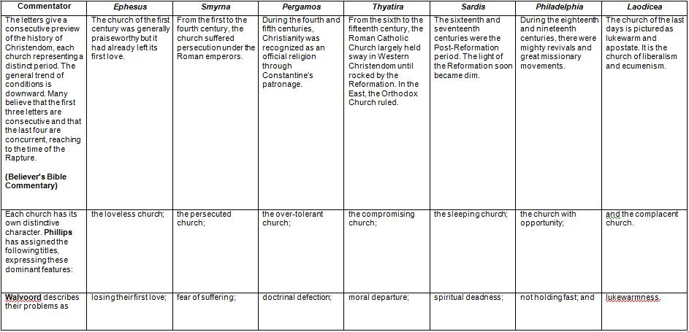
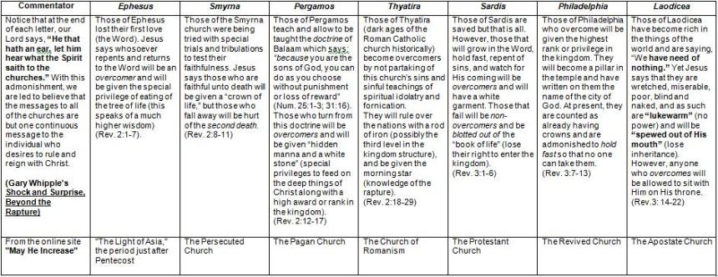

Gary Whipple's further commentary:

The careful student of the Word will see in the first four letters a composite picture of the beginning and ending state of an apostate Christian (one falling away from God). Then in the fifth and sixth letters, he will see the growth of a newborn Christian to full maturity. Then in the seventh a falling away of that Christian due to prosperity and the worship of mammon. The apostasy in the first-four letters begins by leaving the Word, whereas the apostasy of the seventh is the result of prosperity of this world.

Notice the three steps of apostasy in the first-four letters:

(1) The loss of their first love, the Word, which caused them to fall into special trials and tribulations for the purposes of bringing them back.

(2) A further fall into accepting a false doctrine called the doctrine of Balaam (Numbers 31:16).

(3) The final step is accepting the teaching of spiritual idolatry and fornication to such a degree that the apostate does not want Christ to rule over him. Then notice that in the seventh letter the cause for the first step in the fall (leaving the Word) is prosperity and power in this world.
~~~~~~~~~~~~~~~~~~~~~~~~~~~~~~~~~~~~~~~~~~~~~~~~~~~~~~~~~~~~~~~~~~~~~~~~~~~~~
Revelation Chapters 2, 3 Commentary Letters From Our Lord.docx in Table Form.

