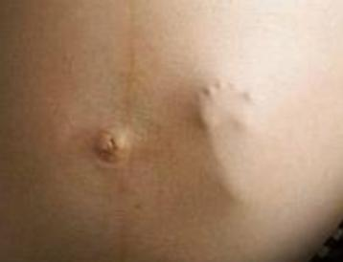

Life after Delivery

In a mother's womb were two babies. One asked the other: "Do you believe in life after delivery?"

The other replies, "why, of course. There has to be something ...after delivery. Maybe we are here to prepare ourselves for what we will be later."

"Nonsense," says the other. "There is no life after delivery. What would that life be?"

"I don't know, but there will be more light than here. Maybe we will walk with our legs and eat from our mouths."

The other says, "This is absurd! Walking is impossible. Eating with our mouths? Ridiculous. The umbilical cord supplies nutrition. Life after delivery is to be excluded."

The umbilical cord is too short. I think there is something and maybe it's different than it is here."

The other replies, "No one has ever come back from there. Delivery is the end of life, and in the after-delivery it is nothing but darkness and anxiety that takes us nowhere."

"Well, I don't know," says the other, "but certainly we will see mother and she will take care of us."

"Mother?" "You believe in mother? Where is she now?"

"She is all around us. It is in her that we live. Without her there would not be this world."

"I don't see her, so it's only logical that she doesn't exist."

To which the other replied, "Sometimes when you're in silence you can hear her. You can perceive her. I believe there is a reality after delivery and we are here to prepare ourselves for that reality....”
~~~~~~~~~~~~~~~~~~~~~~~~~~~~~~~~~~~~~~~~~~~~~~~~~~~~~~~~~~~~~~~~~~
~ Útmutató a Léleknek (Originally written in Hungarian by Útmutató a Léleknek, translated by Miranda Linda Weisz)

