One Kingdom of this World (Babylon) under Different National Powers
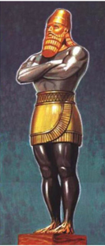

Nebuchadnezzar's Dream (Daniel 2)

The head of gold represents Nebuchadnezzar.

The “breast and arms of silver” represent the Medes and Persians.

The “belly and thighs of brass” represent the Grecians.

The “legs of iron, then feet part of iron and part of clay” represent the Antichrist.

You watched while a stone was cut out without hands, which struck the image on its feet of iron and clay, and broke them in pieces. (Daniel 2:34)

This kingdom is Babylonian throughout. The powers represented by the head of gold, the breast and arms of silver, and the belly and thighs of brass all reigned from Babylon.

Daniel's Vision of Four Great Beasts (Daniel 7)
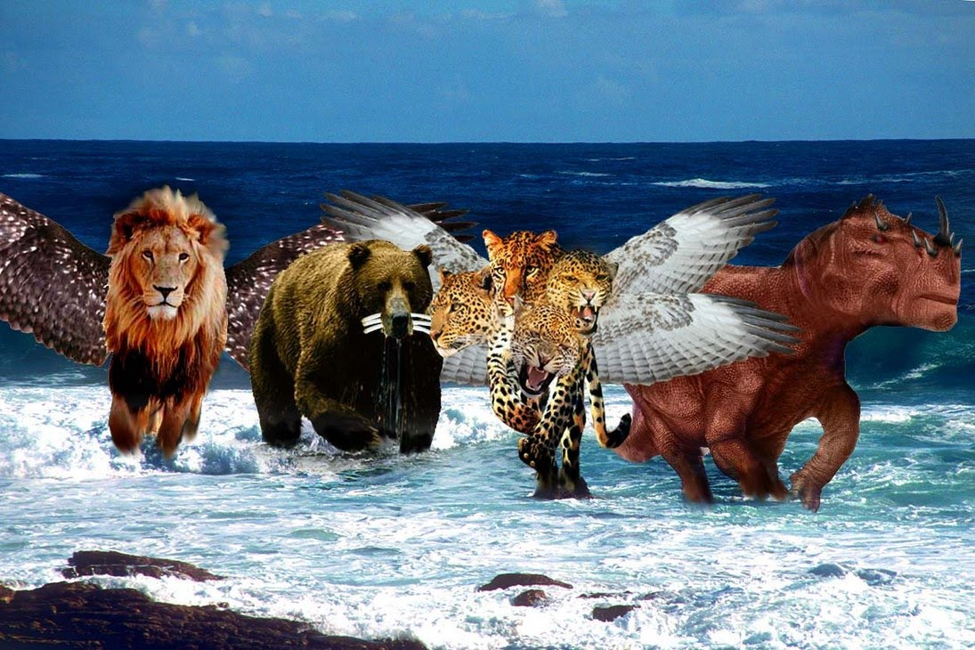
Commentary on the Four Parts of the Great Image and the Four Great Beasts.

Daniel Chapters Two, Seven, and Nine
The Time of Jacob’s Trouble
By Arlen L. Chitwood of Lamp Broadcast

Chapter Three, The End of Gentile World Power

The most widely held position among students of the Word concerning Daniel’s “great image” in Daniel 2 (or the “four great beasts” in Daniel 7) views the four parts of the image (or the “four great beasts”) as representing:

1) Babylon
2) Media-Persia
3) Greece
4) Rome

This would be the position set forth in the Scofield Reference Bible footnotes for example, a position followed by most commentators.

1) Daniel 2; 7

The only part of the prophecy really in question would be the fourth part of the “great image” (Daniel 2), or the fourth “great beast” (Daniel 7). Daniel identifies the first three beasts (and, correspondingly, the first three parts of the image) as particular Gentile nations forming world kingdoms whose governmental rule had been established in Babylon (the first by conquering the Assyrian Empire [the beginning of the Babylonian kingdom under Nebopolassar, then several years later under his son, Nebuchadnezzar], and the latter two by conquering Babylon itself), and this part of the prophecy has been fulfilled and is a matter of history.

But should the fourth part of the image (or the fourth beast) be identified as Rome? There are two main reasons why people interpret the prophecy after this fashion:

1) Rome was the next world power following Greece.

2) The words, “and the people of the prince that shall come shall destroy the city and the sanctuary,” in Daniel 9:26, are usually associated with a Roman destruction in history (by Titus in 70 A.D.) and a Roman prince in prophecy (the beast of Revelation 13, Antichrist).

In this respect, both the historical and prophetic aspects, as they are said to relate to Rome, are connected with the fourth part of the image (or the fourth beast).

Greece was the third kingdom (represented by the belly and thighs of brass on the image); and the fourth kingdom (represented by the legs of iron, and in its final form by the feet part of iron and part of clay) would, from history, seem to be Rome — the next world power following Greece — with the final form of the image looked upon as a revived Roman Empire. And this interpretation would appear to be substantiated by Daniel 9:26.

In this verse, as previously shown, “the prince that shall come,” would be Antichrist; and “the people of the prince [understood as ‘his people’],” who would one day destroy the city of Jerusalem, are looked upon as a reference to the Romans destroying Jerusalem in 70 A.D. under Titus. Thus, Antichrist is said to be a latter-day Roman prince who will rule a revived Roman Empire.

In this respect, all four parts of Daniel’s “great image” except the feet would have a historical fulfillment. The legs would represent the Roman Empire in history, and the feet would represent the revived Roman Empire during the Tribulation.

And the same would hold true for the corresponding description set forth by the “four great beasts” in Daniel 7. The first three beasts would have a historical fulfillment, and the fourth would have a fulfillment in both history and prophecy. The fourth beast would represent the Roman Empire in both history and prophecy, corresponding to the legs and feet of the image.

Is the preceding though the way Scripture sets forth the fourth and final part of this Babylonian kingdom? Or is this an attempt to interpret biblical prophecy through using events in secular history rather than interpreting prophecy by comparing Scripture with Scripture? The answer is easy to ascertain if one remains solely within that which Daniel (and related Scripture) reveals about the whole matter.

Note first of all that Daniel’s image is seen standing in Babylon (Daniel 2:31). This image has to do with a Babylonian kingdom from beginning to end. The “head of gold” has to do with the kingdom of Babylon under Nebuchadnezzar and any immediate successors prior to the conquest of the kingdom by Gentile power(s) represented by the breast and arms of silver (Daniel 2:37-38). The “breast and arms of silver” have to do with the Medes and the Persians coming in and conquering the preceding kingdom (Daniel 2:39; 5:28, 31). And the “belly and thighs of brass” have to do with the Grecians coming in and conquering the kingdom ruled by the Medes and the Persians (Daniel 2:39; 8:6-7, 20-21; 10:20).

The mechanics of the preceding, of course, form the interpretation held in common by almost anyone reading Daniel. This is simply what the record in Daniel states, along with secular history.

But note something often overlooked about the preceding:

This kingdom is Babylonian throughout. The powers represented by the head of gold, the breast and arms of silver, and the belly and thighs of brass all reigned from Babylon.

When the Medes and the Persians came in and took the kingdom in 538 B.C., they reigned from Babylon and were still there when Alexander the Great came over in 330 B.C., two hundred and eight years later. Then, when Alexander the Great took the kingdom, he also reigned from Babylon. In other words, the image is not seen lying down, with the head of gold in Babylon, the breast and arms of silver in Media and Persia, and the belly and thighs of brass in Greece. That’s not the picture at all. The image is seen standing in Babylon. It is Babylonian in its entirety.

(Note that “Babylon” in history was a city-state, which, from biblical prophecy, will evidently exist once again when the final form of Daniel’s image appears [i.e., Babylon existing as a city-state yet future as well]. In this respect, Babylon is used in Scripture referring to both the city and the state, which included [and evidently will include] a number of Middle Eastern cities or countries; cf. Jeremiah 51:29-32, 42-43].)

The fact that the image in Daniel chapter two (Daniel 2) is Babylonian in its entirety is one place where those who view a Roman Empire next in the prophecy go astray. Rome had nothing to do with a reign from Babylon in history. The capital of the Roman Empire was Rome, not Babylon. And Rome is not Babylon, regardless of the attempts by some individuals to see certain things moved from Babylon to Rome in time past, seeking to align and identify Rome with Babylon in this respect.

Those viewing Rome as representing the fourth part of the image try to press secular history into biblical prophecy at a point where it seems to possibly fit, but really doesn’t. Then they further complicate the matter by a misinterpretation of Daniel 9:26.

But the most interesting thing about the whole matter — the central thing that voids all thought of Rome having a part in the prophecy — is the fact that Daniel identifies all four parts of the image, and he identifies the fourth part as being other than the Roman Empire. Daniel, in his identity, has Antichrist coming into power following a four-way division of the kingdom after Alexander the Great’s death. The kingdom under Antichrist follows the Greco-Babylonian kingdom and is represented by the legs of iron, and in its final form by the feet part of iron and part of clay.

(No break in time is seen in the book of Daniel between powers represented by the third and fourth parts of the image, similar to no break in time subsequently being seen in the book between the sixty-ninth and seventieth weeks in Daniel’s Seventy-Week prophecy [Daniel 9:24-27]. However, it is evident from both biblical and secular history that a break in time exists at these respective points in both prophecies, though no break in time precedes these in either prophecy.

This break in time though between the third and fourth parts of the image doesn’t lead to, and end with Rome. Rather, it leads to, and ends with a kingdom in the Middle East, the kingdom of Antichrist. As with Daniel’s subsequent prophecy of the Seventy Weeks, events seen occurring within the prophecy itself cannot occur during the break in time not seen in the prophecy. Events seen in the prophecy must occur within time covered by the prophecy.

For example, the destruction of Jerusalem in Daniel’s prophecy of the Seventy Weeks [Daniel 9:26] must occur within time covered by the prophecy itself, not outside of this time [as the destruction under Titus in 70 A.D. would be]. If this destruction didn’t occur during time covered by the first sixty-nine weeks [which it didn’t], then it must occur during time covered by the seventieth week. And events foreshadowed by the things stated about the great image and the great beasts [Daniel 2; 7] must be understood the same way. [See Seventy Years, Four Hundred Ninety Years and “70 Years, 490 Years”, both in this site.]

In the preceding respect, it is just as impossible to fit Rome into the prophecy regarding the great image and the great beasts [Daniel 2; 7] as it is to fit Titus’ destruction of Jerusalem into the prophecy of the Seventy Weeks [Daniel 9].)

The first part of the image is identified in Daniel 2:37-38. Then, following this, the remaining three parts of the image are presented, though not identified at this point in the book. Then, note the prominence given to the fourth part — two verses cover the first part (Daniel 2:37-38), one verse covers the next two parts (Daniel 2:39), but six verses are devoted to the final part, along with its destruction (Daniel 2:40-45). And such prominence relative to the fourth part is true elsewhere in Daniel as well (see Daniel 7; 8; 11).

Why would such prominence be given to Rome and not to nations associated with the first three parts of the image? It’s not! Rather, it’s the kingdom of Babylon under its last king (Antichrist) that occupies the forefront in the book of Daniel.

The identities of the other three parts of the image, beginning with the breast and arms of silver, are given in the interpretation of the vision of the “four great beasts,” and this interpretation is provided in chapters seven and eight. The “four great beasts” are said to represent four kingdoms (four sequential kingdoms forming the one Babylonian kingdom [Daniel 7:17; cf. Daniel 7:23]), and beginning with the second beast, the last three are identified in chapter eight:

For the identity of the second, compare verses three and four [Daniel 8:3-4] with verse twenty [Daniel 8:20] (cf. Daniel 5:28, 31).

For the identity of the third, compare verses five through eight [Daniel 8:5-8] with verses twenty-one and twenty-two [Daniel 8:21-22].

For the identity of the fourth, compare verses nine through fourteen [Daniel 8:9-14] with verses twenty-three through twenty-six [Daniel 8:23-26].

Note that the identity of the second is Media and Persia (a dual kingdom, corresponding to the breast and arms of silver on the image), the identity of the third is Greece (corresponding to the belly and thighs of brass), and the identity of the fourth is the kingdom under Antichrist (corresponding to the legs of iron and the feet part of iron and part of clay).

Where is Rome? Rome is not in the prophecy!

Following Alexander the Great’s death, the kingdom was divided among his four generals (Daniel 8:8, 22), and the vision then goes immediately into the days of Antichrist yet future (the “little horn” in Daniel 8:9 is not Antiochus Epiphanes, but Antichrist [see parallel verses, Daniel 8:23-26]).

So, what happened? The kingdom under Alexander the Great’s four generals gradually faded from view. And though the prophecy in Daniel chapter eight covers this division of the kingdom following Alexander the Great’s death (Daniel 8:8b), it does not cover events during the reign of these four generals following this division. Rather, following this division of the kingdom, Daniel’s prophecy in chapter eight goes immediately into the power represented by the fourth part of the image (or the power represented by the fourth beast), i.e., into the days of Antichrist (Daniel 8:9ff).

(The same prophetic scene is repeated in Daniel 11:3-4a, 21ff, providing additional details. And whether the verses lying between the division of Alexander the Great’s kingdom in this section [Daniel 11:4a] and the appearance of Antichrist [Daniel 11:21] — i.e. Daniel 11:4-20 [4b] — are looked upon as depicting events during the years following Alexander the Great’s death or depicting events during the several years immediately preceding Antichrist’s rise to power is immaterial insofar as the matter at hand is concerned. Exactly the same thing is seen in chapter eleven as was previously seen in chapter eight. The kingdom seen following the four-way division of Alexander the Great’s kingdom is the same in both chapters — Antichrist’s kingdom, not a Roman kingdom [cf. Daniel 8:8-9, 21-23; 11:4, 21].

The preceding has been worded in the manner seen in order to show, regarding the matter under discussion, that it wouldn’t really make a difference which interpretation of Daniel 11:4-20 [4b] was followed. But to clarify matters regarding the proper interpretation of these verses, Daniel 11:4-20 [4b] has to do with events yet to occur in the future, not with events that have already occurred in the past. These verses provide commentary on previous verses in Daniel having to do with Antichrist’s rise to power during the first half of the Tribulation — subduing, conquering, three kings [Daniel 7:7-8, 24; 8:8-10; 11:4], then three others [Daniel 11:5-20], with Antichrist arising as the seventh [Daniel 11:21ff], exactly as seen in Revelation 12:3; 13:1; 17:8-11.

The first three kings conquered in Daniel chapter eleven [Daniel 11:4] have to do with Alexander the Great’s kingdom following his death [the kingdom was divided among his four generals]. The beast, Antichrist [the “little horn” of Daniel 8:9], coming out of the northern division of this kingdom, is seen subduing “three kings” [cf. Daniel 7:7-8, 24; 8:9-10]. That is, from the standpoint of the way that the matter is set forth in Daniel, he will be seen controlling this northern division of the kingdom and conquer the three kings controlling the other three parts of the kingdom [a kingdom still seen in Scripture as possessing life, still seen as existing, in the end times (cf. Daniel 2:35; 7:12)]. And, conquering these three other kings will give the “little horn,” Antichrist, control of the entire kingdom — something necessary if he is to control the governmental power depicted by the complete image.

Thus, Antichrist’s kingdom [a yet future kingdom, existing during the Tribulation] will emanate out of Alexander the Great’s kingdom [depicted by the third part of the “great image” (Daniel 2) or the third “great beast” (Daniel 7)], not out of that which is depicted by the fourth part of the “great image” or the fourth “great beast.” Knowledge of this fact alone, clearly stated in Daniel, will show that Rome can have no part in the entire matter.

Through the progression of events seen in the book of Daniel, necessitating that they be the same in the book of Revelation, the kingdom of the beast becomes the fourth kingdom, a kingdom that will not exist in any visible form before this man appears on the scene. And this kingdom, of necessity, will be a Middle Eastern kingdom (cf. Psalm 83; Daniel 11), not a Roman kingdom as is so often taught.

For additional information on the preceding, refer to Chapter 25, “The Beast — In Revelation in this site.)

About two hundred and eighty years following Alexander the Great’s death (about 40 B.C.), Rome appeared on the scene as the succeeding world power, but not as a world power fulfilling any part of Daniel’s prophecy surrounding the kingdom of Babylon. This prophecy will not again continue to be fulfilled until Antichrist appears during Daniel’s Seventieth Week. Then, and only then, will the fourth part of the image from Daniel 2 and the fourth beast in Daniel 7 come into existence.

2) Daniel 9

Now, what about “the people of the prince who is to come” in Daniel 9:26? Does that not refer to a destruction of Jerusalem in 70 A.D. and to the Romans being Antichrist’s people in history?

Not at all!

First note the expression, “the people of the prince who is to come,” and compare this with a similar expression in Daniel 7:27 KJV — “the people of the saints of the most High [lit. ‘the high places’ (also plural in the Hebrew text in Daniel 7:18, 22, 25b)],” who will one day take the kingdom (Daniel 7:18).

Note in verse eighteen (Daniel 7:18) that the ones who will one day take the kingdom are said to be “the saints of the most High [‘the high places’],”and in verse twenty-seven (Daniel 7:27) they are said to be “the people of the saints of the most High [‘the high places’].” The expression, “the people of the saints of the most High [‘the high places’]” in verse twenty-seven (Daniel 7:27) is, contextually, a reference to the saints themselves from verse eighteen (Daniel 7:18).

And this same type of expression in Daniel 9:26 should be understood in the same way that interpretation has already been established in the previous chapter of the book. The expression, “the people of the prince” in Daniel 9:26, contextually, has to be understood as a reference to the prince himself (and possibly also including those ruling with him). Failure to recognize the book’s own built in interpretation for Daniel 9:26 has resulted in confusion.

The destruction of Jerusalem in Daniel 9:26 (a destruction occurring outside the scope of Daniel’s Seventy-Week prophecy), as previously seen, is not a reference to the destruction that occurred in 70 A.D. but rather a reference to a future destruction under Antichrist in the middle of the Tribulation. This is the same destruction referred to in Luke 21:20-24 (cf. Revelation 11:2). Also note that Matthew 24:15ff and Luke 21:20ff parallel one another, depicting events in and around Jerusalem beginning in the middle of the Tribulation. Matthew’s gospel centers on one aspect of the matter (the rebuilt Temple on the Temple Mount in Jerusalem), and Luke’s gospel centers on another aspect of the matter (the city of Jerusalem itself).

The destruction in Daniel 9:26 must occur within the framework of time covered by the Seventy Weeks. This destruction has to do with events occurring in connection with Daniel’s prophecy of the Seventy-Weeks and can only occur during time covered by this prophecy, and contextually it occurs in connection with Antichrist breaking his covenant with Israel in Daniel 9:27 (cf. Daniel 11:22-32; 12:11; Matthew 24:15; 2 Thessalonians 2:3-4; Revelation 6:3-4).

And where this man’s actions will then lead is outlined in detail in both the books of Daniel and Revelation, along with a number of other books and numerous sections of Scripture. This is the man whom God, in the final analysis, will use to bring His plans and purposes surrounding Israel to pass. Despite this man’s goals, aims, ambitions, and aspirations — as he exercises power and great authority from Satan’s throne itself (Revelation 13:2) — God, in His sovereign control of all things, will use this man to bring both Israel to the place of repentance and Gentile world power to the place of destruction.

This will be followed by God’s judgment falling upon this man, on the basis of the unchangeable principles set forth in Genesis 12:3.

Then, God’s firstborn Sons — Christ, Israel, and the Church (following the adoption) — will occupy their proper places on and over the earth during the ensuing Messianic Era.

Note: The lion represents Babylon (Daniel 7:4), the bear Medo-Persia (Daniel 7:5), the leopard Greece (Daniel 7:6) and the fourth beast Antichrist (Daniel 7:8, 20; 8:9).
~~~~~~~~~~~~~~~~~~~~~~~~~~~~~~~~~~~~~~~~~~~~~~~~~~~~~~~~~~~~~~~~~~~~~~~~~~~~~
The Time of Jacob's Trouble by Arlen Chitwood
Bible One - Arlen Chitwood's The Time of Jacob's Trouble, Ch. 3, The End of Gentile World Power
To

