Peter is not the rock.
The Greek words for Peter and for rock are similar,
but the meanings are different.
The first, petros, means a stone or loose rock;
the second, petra, means rock, such as a rocky ledge.
So what Jesus really said was “you are Peter (stone),
and on this rock I will build My church.”
He did not say He would build His church on a stone, but on a rock.

Rock: Deut 32:4. See also 1 Sa 2:2; 2 Sa 22:2; Ps 62:2; Ps 78:35, 1 Cor 10:4.

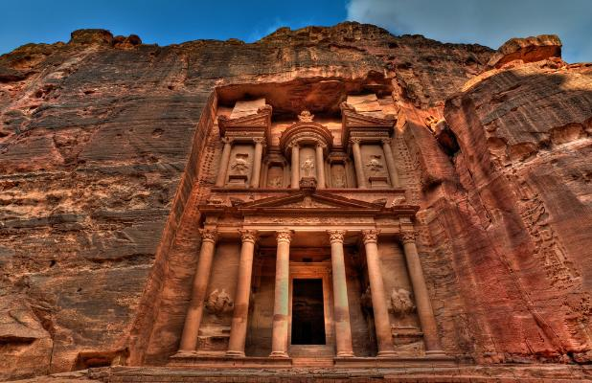
Ancient City of Petra [Rock], Jordan.

Peter and the rock!
By Believer's Bible Commentary

Jesus answered and said to him, "Blessed are you, Simon Bar-Jonah, for flesh and blood has not revealed this to you, but My Father who is in heaven. (Matthew 16:17)

And I also say to you that you are Peter, and on this rock I will build My church, and the gates of Hades shall not prevail against it. (Matthew 16:18)

Our Lord pronounced a blessing on Simon, son of Jonah. The fisherman had not arrived at this concept of the Lord Jesus through intellect or native wisdom; it had been supernaturally revealed to him by God the Father. But the Son had something important to say to Peter also. So Jesus added, “And I also say to you that you are Peter, and on this rock I will build My church, and the gates of Hades shall not prevail against it.” We all know that more controversy has swirled around this verse than almost any other verse in the Gospel. The question is, “Who or what is the rock?” Part of the problem arises from the fact that the Greek words for Peter and for rock are similar, but the meanings are different. The first, petros, means a stone or loose rock; the second, petra, means rock, such as a rocky ledge. So what Jesus really said was “you are Peter (stone), and on this rock I will build My church.” He did not say He would build His church on a stone but on a rock.

If Peter is not the rock, then what is? If we stick to the context, the obvious answer is that the rock is Peter's confession that Christ is the Son of the living God, the truth on which the church is founded. Ephesians 2:20 teaches that the church is built on Jesus Christ, the chief cornerstone. Its statement that we are built upon the foundation of the apostles and prophets refers not to them, but to the foundation laid in their teachings concerning the Lord Jesus Christ.

Christ is spoken of as a Rock in 1 Corinthians 10:4. In this connection, Morgan gives a helpful reminder:

Remember, He was talking to Jews. If we trace the figurative use of the word rock through Hebrew Scriptures, we find that it is never used symbolically of man, but always of God. So here at Caesarea Philippi, it is not upon Peter that the Church is built. Jesus did not trifle with figures of speech. He took up their old Hebrew illustration—rock, always the symbol of Deity—and said, “Upon God Himself —Christ, the Son of the living God—I will build my church.”

Peter never spoke of himself as the foundation of the church. Twice he referred to Christ as a Stone (Acts 4:11-12; 1 Peter 2:4-8), but then the figure is different; the stone is the head of the corner, not the foundation.

“I will build My church.” Here we have the first mention of the church in the Bible. It did not exist in the OT. The church, still future when Jesus spoke these words, was formed on the Day of Pentecost and is composed of all true believers in Christ, both Jew and Gentile. A distinct society known as the body and bride of Christ, it has a unique heavenly calling and destiny.

We would scarcely expect the church to be introduced in Matthew's Gospel where Israel and the kingdom are the prominent themes. However, consequent to Israel's rejection of Christ, a parenthetical period—the church age—follows and will continue to the Rapture. Then God will resume His dealings with Israel nationally. So it is fitting that God should introduce the church here as the next step in His dispensational program after Israel's rejection.

“The gates of Hades shall not prevail against it” may be understood in two ways. First the gates of Hades are pictured in an unsuccessful offensive against the church—the church will survive all attacks upon it. Or the church itself may be pictured as taking the offensive and coming off the victor. In either case, the powers of death will be defeated by the translation of living believers and by the resurrection of the dead in Christ.

e-Sword by Rick Myers and e-Sword Downloads

