Why God Made Dogs
When God had made the Earth and Sky, the flowers and the trees,
He then made all the animals, and all the birds and bees.
And when His work was finished, not one was quite the same,
He said, "I'll walk the Earth of mine, and give each one a name."
And so He traveled land and sea, and everywhere He went,
a little creature followed Him, until it's strength was spent.
When all were named upon the Earth,
and in the sky and sea, the little creature said,
"Dear Lord, there's not one left for me."
The Father smiled and softly said, "I've left you 'til the end,
I've turned my name from back to front, and called you DOG, my friend."
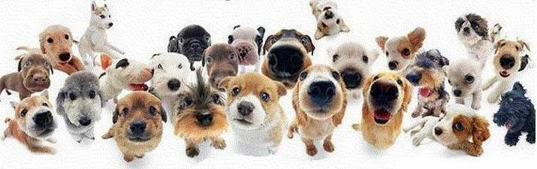
God spelled back to front!

